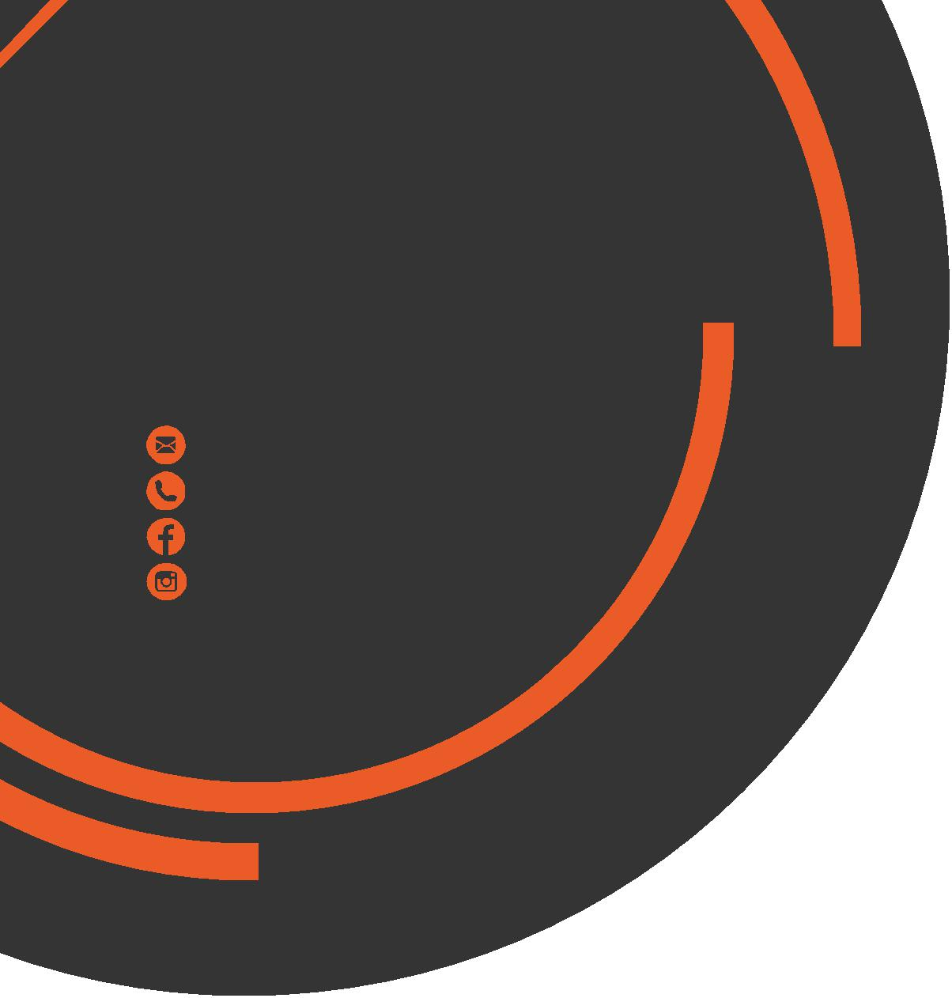

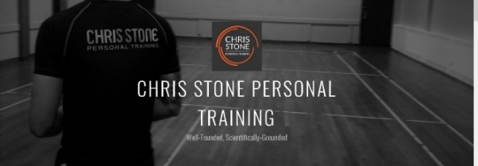
May
Newsletter
chris.stone@nuffieldhealth.com
07954113939

facebook.com/chrisstonept

chrisstonept

Cardio or Weights First?

Before I get to the heart of the matter, let’s first think about fuelling exercise…

Glucose and Glycogen
Glucose and Glycogen are the primary energy sources used by the body. The average human can store approximately 450 - 500g of glycogen which will serve as an energy reserve.

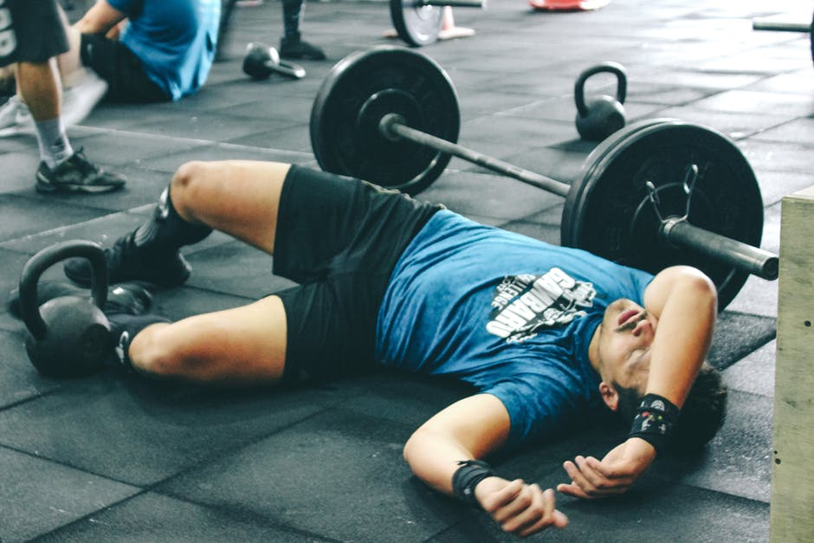
“Hitting the wall”
As exercise duration and intensity increases, glycogen will begin to deplete causing the individual to experience a lack of energy, extreme fatigue and drop in performance.

For more articles like this, visit:
chrisstonepersonaltraining.com

In order to maintain performance, the body will produce catabolic hormones which break down protein in order to sustain provision of energy. However, this process does not provide the body with the nearly the same amount of energy as glycogen which will impact performance.

Additionally, as the muscles are exposed to a high load over a prolonged period, muscular fatigue will begin to build. This is where the muscles are no longer able to sustain or create the same amount of force as previous.

Resistance Training as the Foundation

Whether it be fat loss, rehabilitation or improving overall health, the foundation of your training should be resistance – this is unless your fitness goal a cardio based goal. In many cases, cardio should be used to compliment your strength training and should not form the foundation of your training.

Taking into account the above points in regards to limited energy stores, muscular fatigue and now the notion that resistance training needs to form the foundation of training, it would make sense to focus our energy on resistance first and complete any cardio second – in the majority of cases.

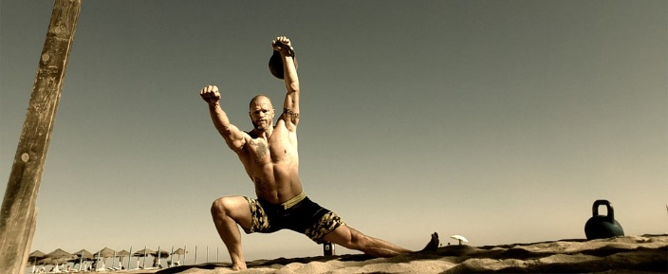

Hip
Movement

You may hear people refer to their hip flexors or abductors from time to time.
Do you know the about the different muscle groups and the movements they control?
Hip Adductors
Major Muscles: Adductor Brevis, Adductor Longus, Adductor Magnus, Gracilis and Pectineus
k
These muscles are found on the inside of the upper leg and are responsible for pulling the leg in towards the midline of the body.
Hip Abductors
Major Muscles: Gluteus Medius, Gluteus Minimus, Tensor Fasciae Latae, Sartorius
k
The Abductors (bar the sartorius - which runs across the front of the thigh) run down the outside of the leg and are responsible for movement of the leg out to the side of the body.
Hip Flexors
Major Muscles: Iliacus, Psoas Major, Rectus Femoris
k
The Iliacus and Psoas Major (or Iliopsoas) are deep set muscles which originate from the pelvis and spine whilst the Rectus Femoris is one of four quadricep muscles. When Hip Flexors contract they move your leg in front of the body.
Hip Extensors
Major Muscles: Gluteus Maximus, Semimembranosus, Semitendinosus, Biceps Femoris
k
The Gluteus Maximus is the biggest muscle found in your backside. Whilst the Semimembranosus, Semitendinosus and Biceps Femoris are the three muscles of the hamstrings. The extensors, when contracted, drive the leg behind the body.
------------------------------------------------------------------------------------------------------------------------------------------------
If you would like to know more about Personal Training, please fill in your details, tear off the slip and hand it in to reception. A member of the PT Team will contact you as soon as possible.
Name: ____________________________________________________________________________________

Phone number: ____________________________________________________________________________

Email address: _____________________________________________________________________________

