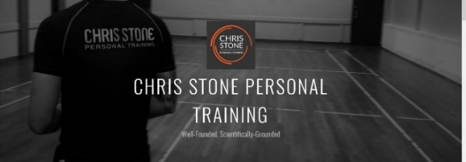
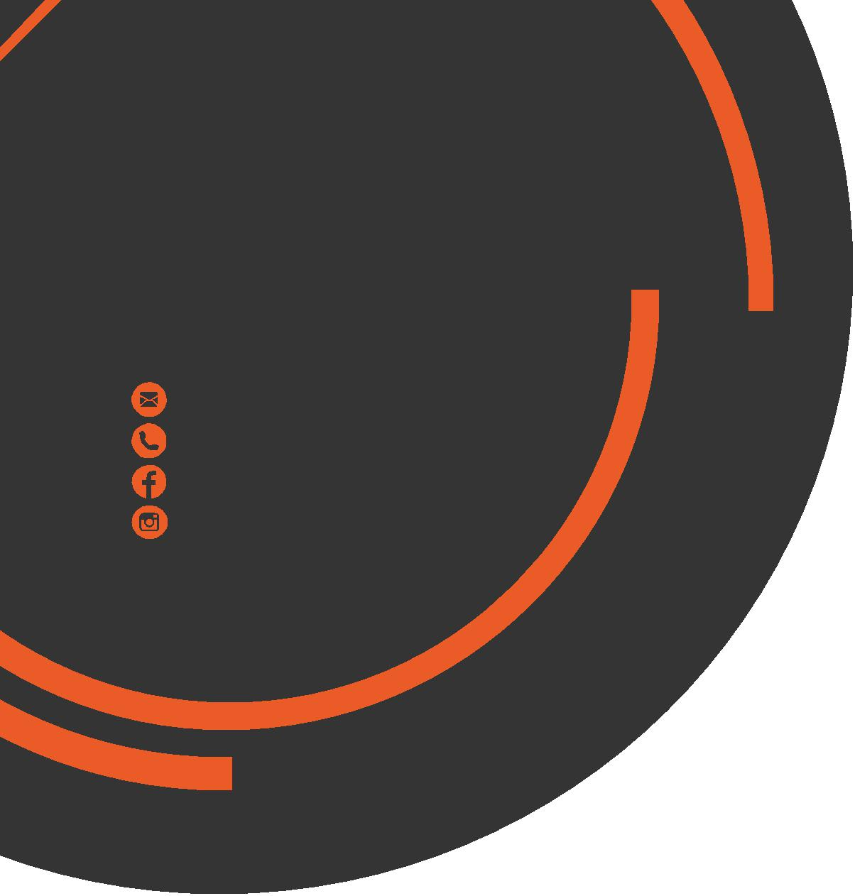
March
Newsletter

chris.stone@nuffieldhealth.com
07954113939

facebook.com/chrisstonept

chrisstonept

Fuelling Exercise

I was having a discussion with one of my clients recently about the importance of eating prior to exercise to which she asked...

"Well, what exactly should I be eating?"

Understanding Glucose

To be able to answer that question we first need to understand how the body is fuelled.

Glucose is blood sugar and is the primary energy source used by the body. Glucose fuels numerous processes such as muscular contraction and relaxation, respiration, body temperature regulation and brain function.
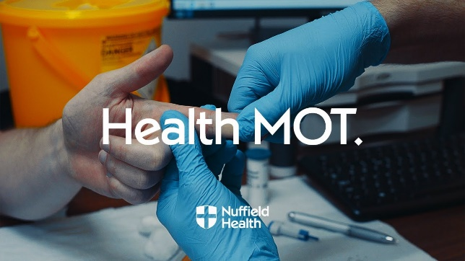

For more articles like this, visit:
chrisstonepersonaltraining.com

Occasionally, I have had to cut a session short as my client has began to feel light-headed or dizzy. In the majority of occasions this because the individual has not eaten for an extended period.

Your body can synthesise glucose, however your glucose levels are significantly impacted by your diet and meal timings. If you don't eat for a prolonged period of time your glucose levels will drop. Therefore the body will struggle to maintain normal functions and cope with the demands of exercise.

Recommendations:
- Aim to consume a proper meal at least 2 to 4 hours prior to exercise
- If this is not possible, aim to eat a small snack prior to exercise
(i.e nuts, fruit, granola, yogurt, crackers, rice cakes or bread)
- Avoid eating a large meal too close to an exercise session

Interested in assessing your Blood Glucose levels?

Book your Health MOT Today.

Time to think
about PT?
A Recent
Scientific Study


Effect of Supervised, Periodised Exercise Training vs. Self-Directed Training on Lean Body Mass and Other Fitness Variables in Health Club Members (2014)
------------------------------------------------------------------------------------------------------------------------------------------------
If you would like to know more about Personal Training then please fill in your details, tear off the slip and hand it in to reception. I will contact you as soon as possible.
Name: ____________________________________________________________________________________

Phone number: ____________________________________________________________________________

Email address: _____________________________________________________________________________

