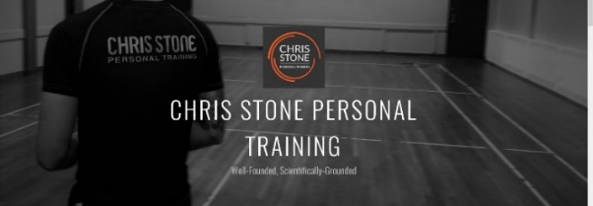


February
Newsletter
chris.stone@nuffieldhealth.com
07564666471

facebook.com/chrisstonept

chrisstonept

Essential Exercises for Shoulder Strength
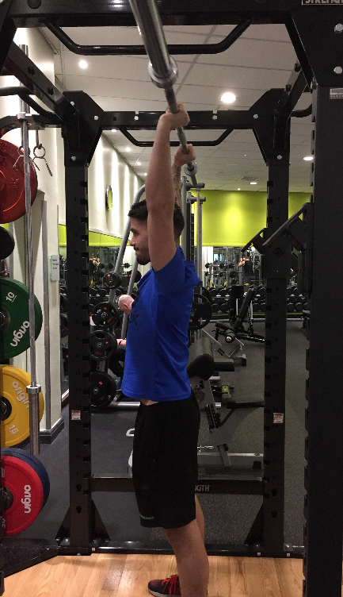
Overhead Press

The king of shoulder exercises. This big compound lift has a great impact on not just the shoulders but also the back, chest and core too.

Top Training Tip: Squeeze the glutes and core throughout to give you a solid base from which you can press from and to stop the hips coming forward.

For more articles like this, visit:
chrisstonepersonaltraining.com

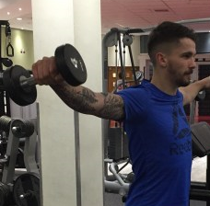
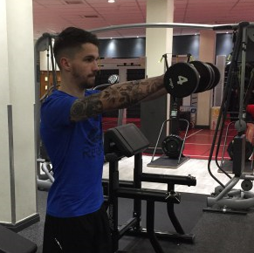
Lateral / Front Raise
I have grouped these two together. These are two individual exercises by their own right, however the movements and form are almost identical with the only difference being the direction in which the arm lifts.

Top Training Tip: Give the “L-Raise” a try – which is a simultaneous lift combining both the front and lateral raise.

Face Pull

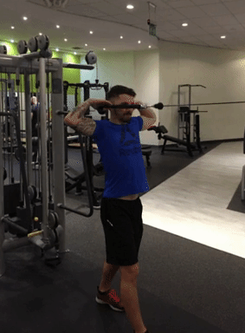
The face pull is not only great for maintaining healthy shoulders but it also works the rhomboids in the upper back.

Top Training Tip: Use a staggered stance to prevent the weight pulling you forward and out of position.

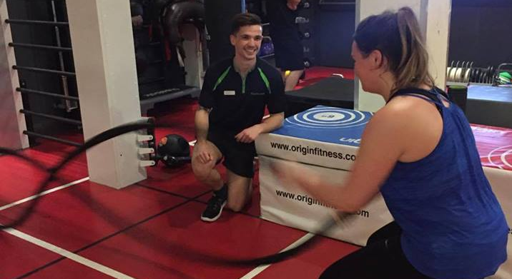

Time to think
about PT?
A Recent
Scientific Study
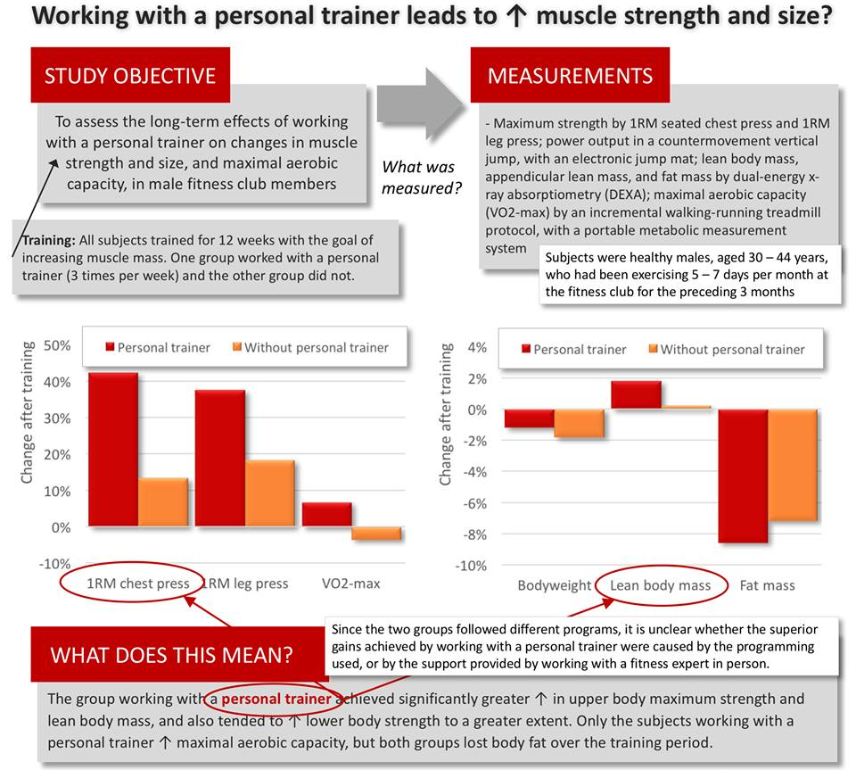
Effect of Supervised, Periodised Exercise Training vs. Self-Directed Training on Lean Body Mass and Other Fitness Variables in Health Club Members (2014)
------------------------------------------------------------------------------------------------------------------------------------------------
If you would like to know more about Personal Training then please fill in your details, tear off the slip and hand it in to reception. I will contact you as soon as possible.
Name: ____________________________________________________________________________________

Phone number: ____________________________________________________________________________

Email address: _____________________________________________________________________________

