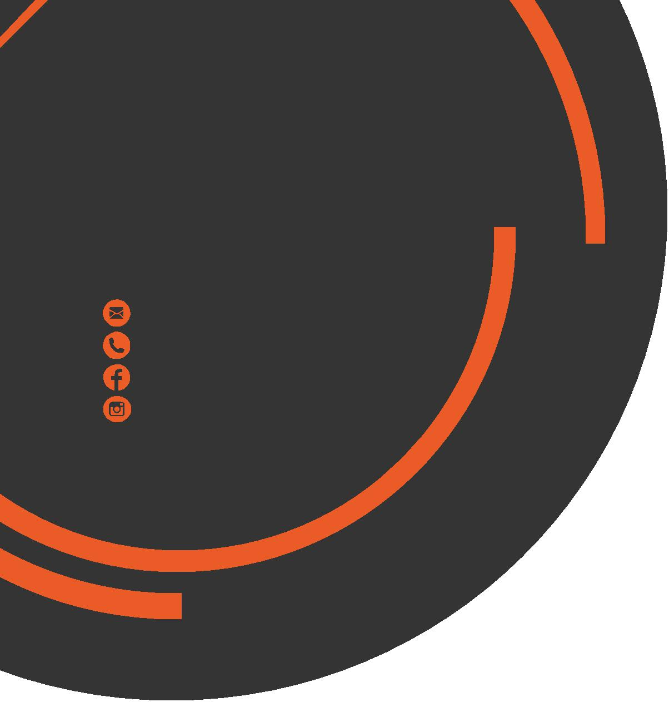
January
Newsletter
chris.stone@nuffieldhealth.com
07564666471

facebook.com/chrisstonept

chrisstonept

Happy 2018!

Accompanying the New Year comes numerous plans to improve fitness and become healthier. Typically, people start strong and are able stick to their new routine for a few weeks or months but gradually fall away and back into their old unhealthy habits.
4 tips to avoid falling into the trap
1) Be Specific
Individuals who set themselves goals are far more likely to achieve success than those who don’t. It will give you a purpose and drive in your training. Make sure your goal is specific and not too broad. For example, “to become healthier” is perhaps to broad a range – how specifically do you intend to become healthier? A more specific goal would be something like “lose 5kg” or “complete a 10k run in under 50 minutes”.

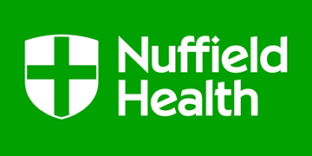

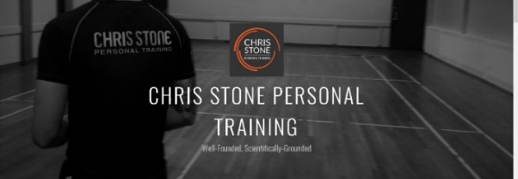

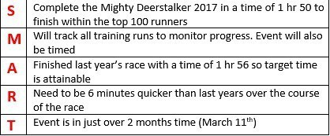
For more articles like this, visit:
chrisstonepersonaltraining.com
An Example of my Goals for this year
2) Ensure your Goals are Realistic

Failing to hit goals or targets is disappointing and can cause you to lose focus and motivation whereas regularly hitting achievable targets and goals can provide further motivation and drive. The goal you set needs to be challenging however not impossible.

3) Track Progress
There is no way of ensuring you’re progressing in the way you want without tracking. I’d recommend that you note down your workouts and also take some physical measurements so you have can track progress and also have data to reflect on in the coming months.

4) Don’t Give Up, Change Takes Time

Whatever you do, if you take nothing away from this newsletter, please remember this point. Many people are too quick to quit when they don’t see instant progress. Change will not happen overnight. It can be a long, arduous process but it’s worth it – stick at it!

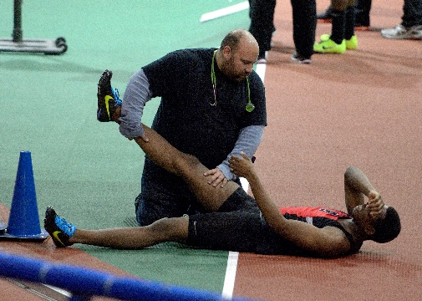
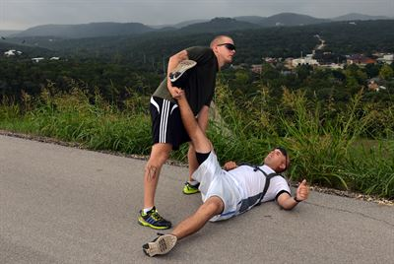
Cramp
101
What is cramp?
Cramp is a muscular spasm which is often onset through exercise. The muscle contracts and then fails to relax leaving the muscle in a contracted state which causes intense pain and leaves the muscle extremely tight.
What does Science Say?
Scientist actually don’t know for definite what causes cramps but there are two main theories - Sweating / Electrolyte Depletion and Muscular Overload and Fatigue.
The Sweating / Electrolyte Depletion theory is that during strenuous exercise the body loses many electrolytes through sweat and this deficiency in electrolyte imbalance is what can onset cramp. Electrolytes are chemicals which carry the ability to conduct electricity and are required for production of energy and maintenance of cell function. This is probably the most commonly quoted theory when it comes to muscular cramp – however, it lacks solid scientific evidence.
The Muscular Overload and Fatigue theory is based on changes in neuromuscular activity that occurs when fatigue kicks in. Neuromuscular Activity refers to the relationship between the body’s control of muscles through the nervous system. The theory is that an imbalance occurs between the control of impulses to relax and contract the muscle or in simpler terms, there is a mix up in communication causing the muscle to stay contracted when it ought to relax. Once again, the scientific backing for this theory is lacking, however, this theory does carry more weight than the Electrolyte theory.
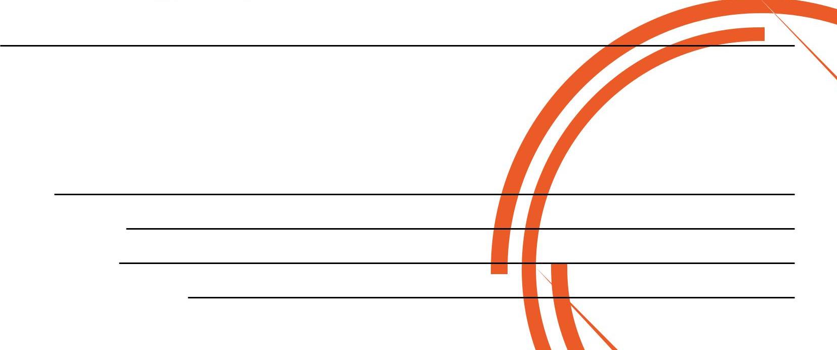
If cramp hits, stretch the muscle as best you can as the muscle must be “manually” relaxed from it’s contracted state. Massage has also been found to help relieve the cramp. In terms of avoiding cramp, it is difficult to avoid without knowing the causation. Regular stretching, maintaining hydration and electrolyte levels may not have a huge impact on the risk of developing cramp but it certainly will not harm your chances.
If you would like to book in for a Complimentary Personal Training Session please fill in your details, tear off the slip and hand it in to reception and I will contact you as soon as possible.
Alternatively, please feel to get in contact with me directly at chris.stone@nuffieldhealth.com

Name:
Phone number:
Email address:
Preferred day and time:

