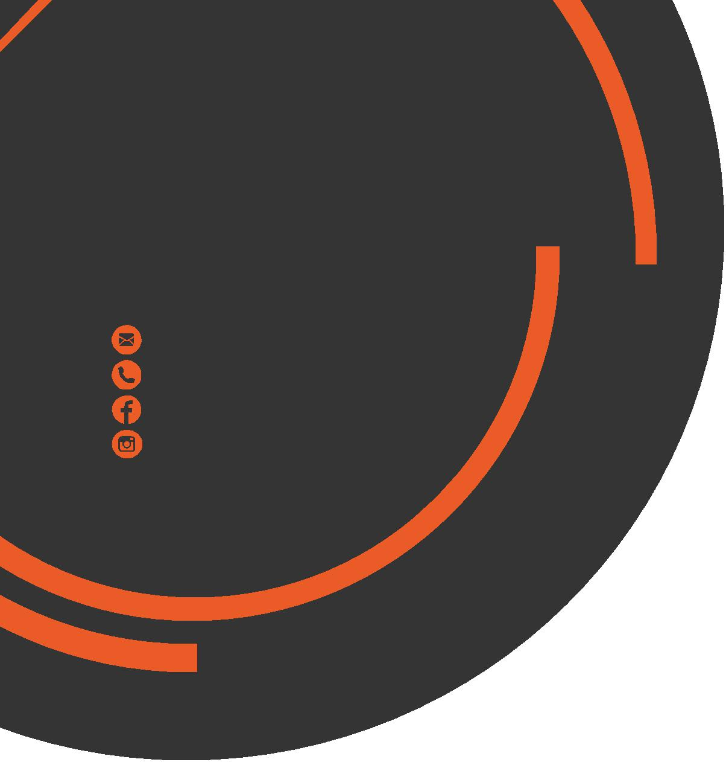
December
Newsletter
chris.stone@nuffieldhealth.com
07564666471

facebook.com/chrisstonept

chrisstonept

Essential Exercises for a
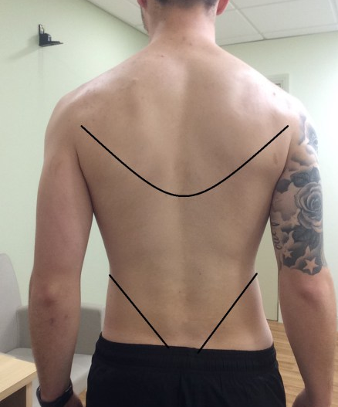
Strong Back

Major Muscles of the Back

Latissimus Dorsi – Big wing-like muscles of the back which assist with pulling and reaching
Trapezius – Thick triangular muscles which controls movement of shoulders, scapula, neck and head
Rhomboids – Smaller band of muscle found in the upper back which control movement of the scapula
Erector Spinae – long muscles which control extension of the back, help to maintain good posture and protection the spine


Go to:
chrisstonepersonaltraining.com
For a visual demonstation
of the following exercises!

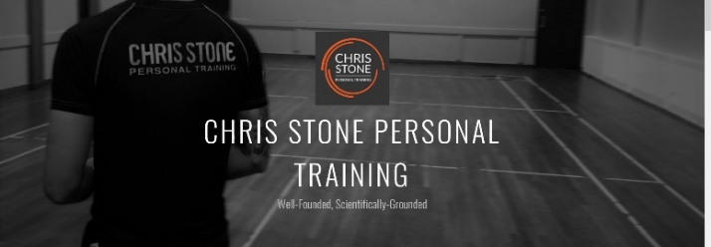

1) Bent Row
Targeted Back Muscles: Lats, Rhomboids, Trapezius

– Feet under hips, slight bend in the knees, hinge the hips, abs tight, chest lifted
–Underhand or overhand grip, pull bar into the area between the chest and stomach
- Keep the elbows tucked in close to the ribs and push elbows out behind the back
2) Lat Pulldown
Targeted Back Muscle: Lats

– Pad tight on the thighs
– Grasp the bar slightly wider than shoulder width
– Push the chest up and lean back slightly to maintain a slight arch in the back
– Drive the bar down to the upper chest, elbows pointed towards the floor, keep upper body tight
– Return to the starting position
3) Deadlift
Targeted Back Muscle: Erector Spinae

– Feet directly under the bar
– Chest up, hinge the hips, reach down, grasp the bar at shoulder width using a reverse grip
– Keep the hips high and the shoulders over bar
– Engage the core, drive through the heels, keeping the bar close to the body throughout
– Push the hips through by squeezing the glutes
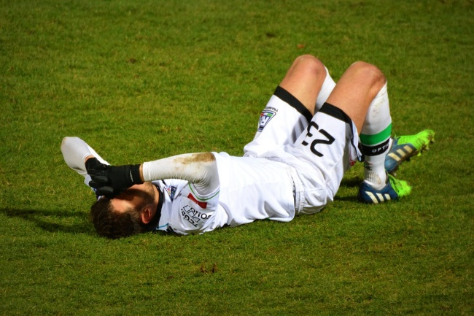

Injury
and
Recovery

How does the body react when injury occurs?
The body has numerous protective responses as a result of injury which include:
Pain – To alert the body that damage has been done to nerve fibers in a given area
Redness – Vasodilation (expanding blood vessels) as a result of damage to vessels
Inflammation – Occurs in order to protect the injured site from further damage
Heat – Blood flow increases to injured site causing increase in heat
Loss of Function – Impaired movement and strength as a result of pain and inflammation
Treatment of Injury
( P R I C E )
Protect – It is crucial that the injured site is either immobilised or stabilised in order to avoid further damage. This is often done using tape, bandages and slings
Rest – Injuries take time to heal. The process can be quickened by ensuring that the site has adequate time and rest. Avoid or reduce physical activity for as long as necessary
Ice – The application of ice or cold to the area will cause vasoconstriction (reduction of blood vessel size) which will reduce blood flow to the site which can help reduce inflammation and pain
Compression – Wraps, bandages and tapes can be used to keep the swelling down whilst also protecting the injured site
Elevation – Raising the injured site above heart level will help to reduce the overall blood volume reaching the injured site and therefore reduce inflammation and pain
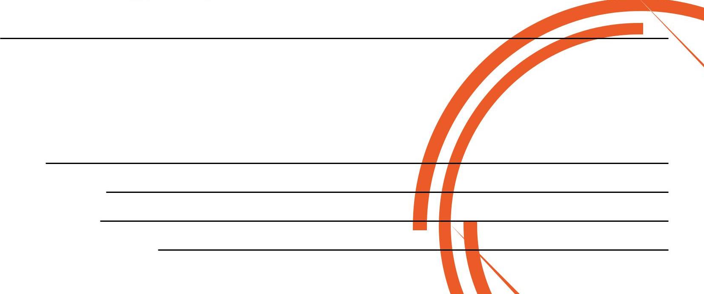
NEVER combine all 5 as it can cause too drastic a reduction of blood flow to the injured site.
A selection of these will suffice and can help to manage injury and promote recovery.

If you would like to book in for a Complimentary Personal Training Session please fill in your details, tear off the slip and hand it in to reception and I will contact you as soon as possible.
Alternatively, please feel to get in contact with me directly at chris.stone@nuffieldhealth.com

Name:
Phone number:
Email address:
Preferred day and time:

