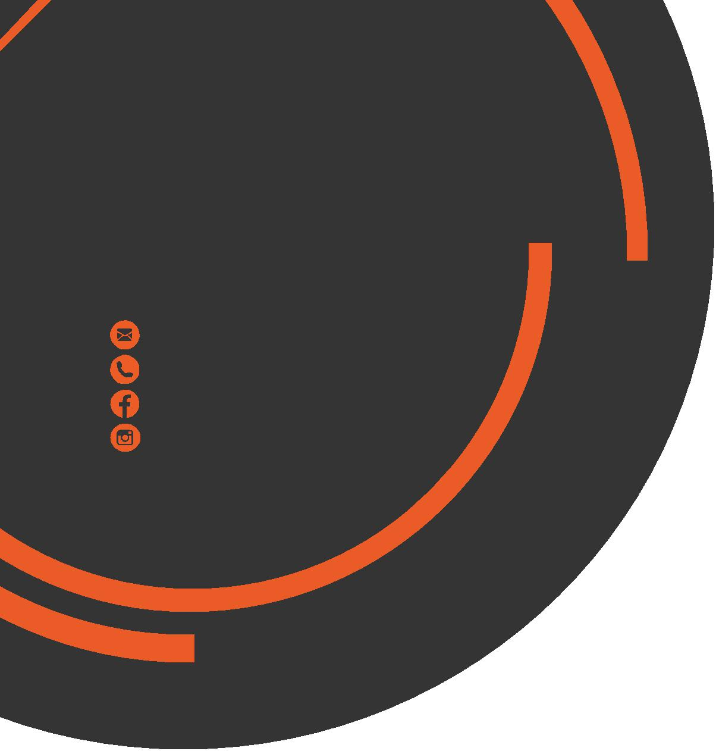
November
Newsletter
chris.stone@nuffieldhealth.com
07564666471

facebook.com/chrisstonept

chrisstonept

Do I Need Protein Shakes?
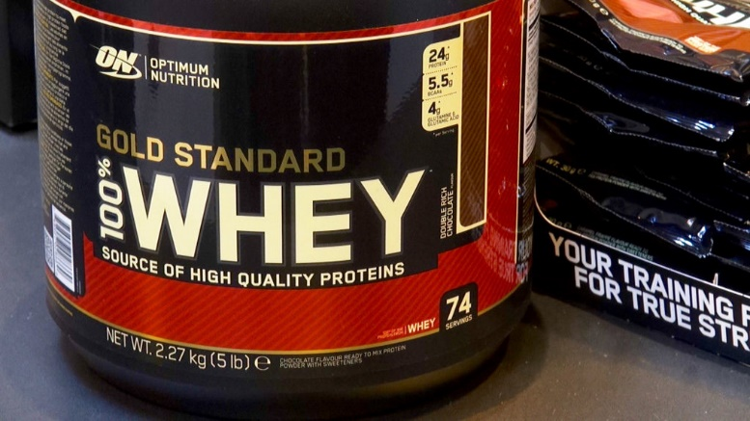
The world of supplements can be a confusing place. By simply typing the word “Protein” into Google, I have 414,000,000 hits and am bombarded with countless ads promoting the latest and greatest powders that money can buy.
It is true that protein plays a crucial role within the body. It is often referred to as the “building block” of the body as it plays an important role in the maintenance and repair of body tissues and structures. Therefore, it is necessary that we have an adequate intake per day… however do we really need additional protein products?


Read more at:
chrisstonepersonaltraining.com

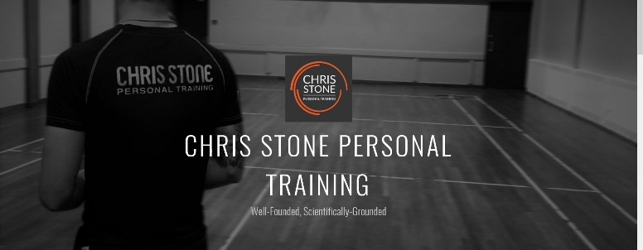

Post-Workout Protein
It is importance to consume protein after a workout however don’t stress too much over protein timing. It is better to focus on getting an adequate amount of protein throughout the day rather than the timing of the protein intake. Protein must be consumed so that the body can begin to recover from the stress of a workout. When the body is exposed to a training stimulus, micro-tears appear within the muscle fibres. For repair to occur, protein is required. An inadequate amount of protein can potentially cause a slower recovery after training.
So, Do I Need Protein Shakes?
It is possible to acquire the adequate amount of protein through diet alone. We need to remember that these products are known as supplements for a reason. They should be SUPPLEMENTARY to your overall diet and shouldn’t be over-relied on.
Protein shakes are quick, easy and convenient source of protein and in terms of practicality they are useful. If you are consuming an adequate amount of protein through your diet then there is no need to start taking protein supplements. However, I would recommend them to those who struggle to consume enough protein per day.

The
Rotator
Cuff
Nutritional Nugget
“Low Fat” / “Light” Products
Be aware that any product classed as Low fat’ contain less than 3% fat whereas a ‘light’ product means that it contains 30% less fat than the original product.
k
This does not necessarily equate to less calories.
In fact, some light / low fat products can contain the same amount or even more calories than the original.
You may have heard people refer to the rotator cuff before and you may be aware that the RC can be found in the shoulder area, but do you know which muscles help to form the RC and which movements they assist with?
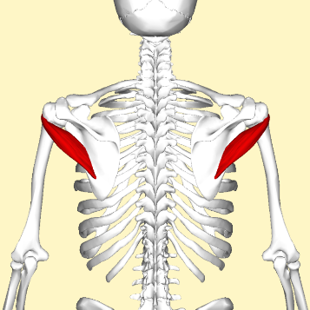
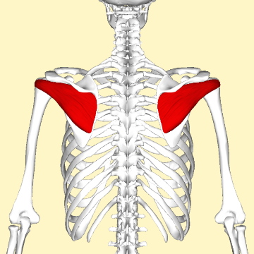
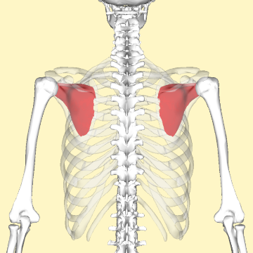
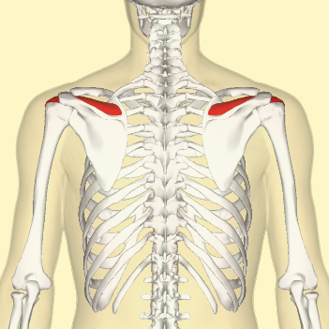
The RC is made up of 4 independent muscles which all originate from the scapula (shoulder blade) and insert onto the humerus (upper arm):
- Supraspinatus – Subscapularis – Infraspinatus - Teres Minor
- Small Muscle - Largest/Strongest - Triangular Muscle - Smallest Muscle
- Adduction - Abduction - External Rotation - External Rotation - Internal Rotation
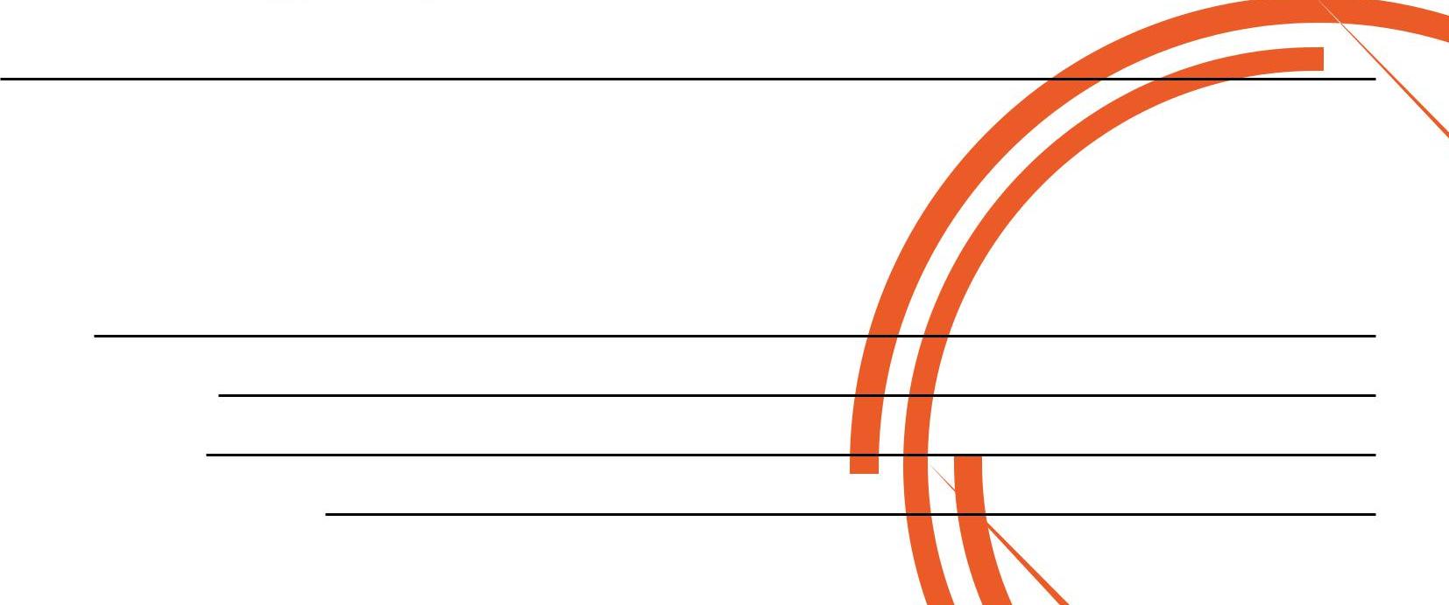
Abduction = Movement of the arm away from the body
Adduction = Movement of the arm towards the midline of the body
Internal Rotation = Rotation of shoulder moving arm towards the midline of the body
External Rotation = Rotation of the shoulder moving arm away from the body

If you would like to book in for a Complimentary Personal Training Session please fill in your details, tear off the slip and hand it in to reception and I will contact you as soon as possible.
Alternatively, please feel to get in contact with me directly at chris.stone@nuffieldhealth.com

Name:
Phone number:
Email address:
Preferred day and time:

