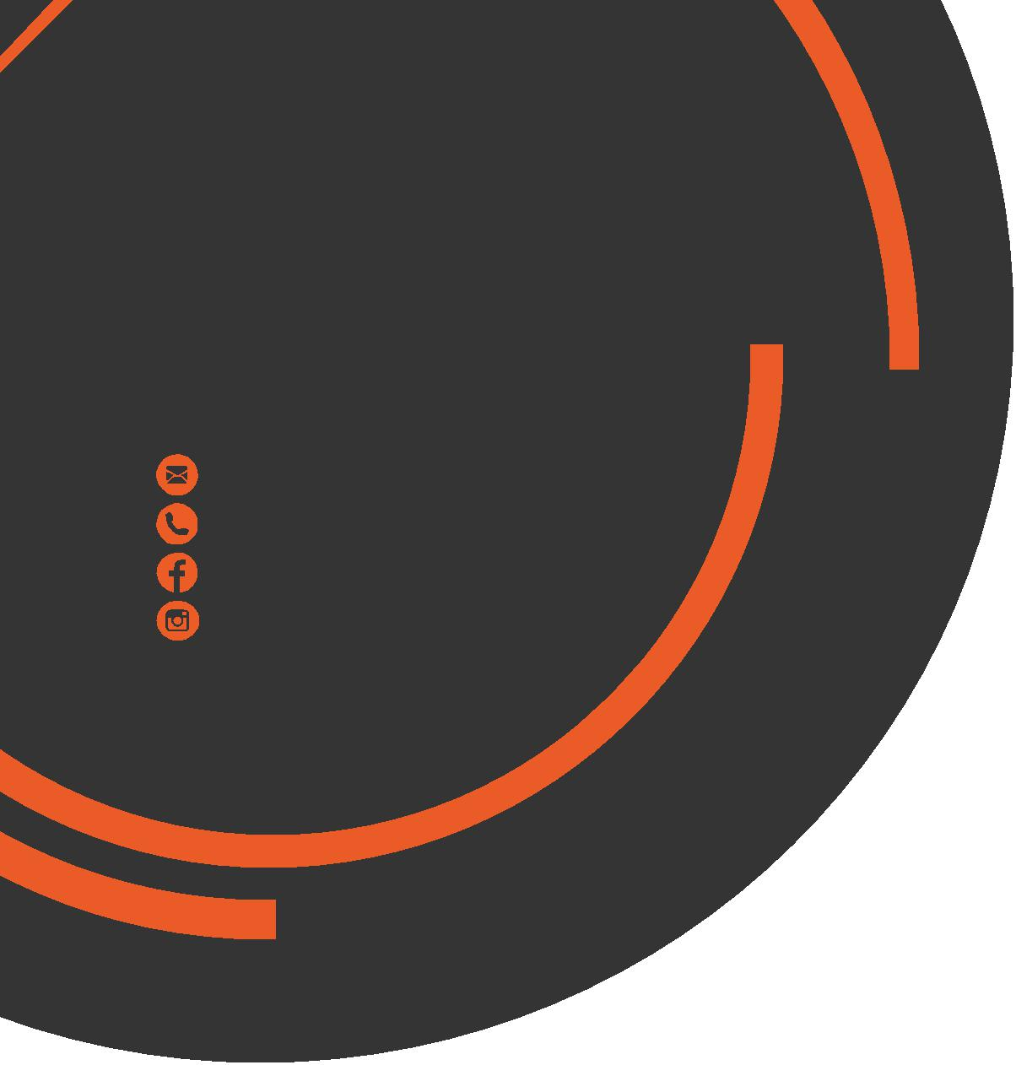
October
Newsletter
chris.stone@nuffieldhealth.com
07564666471

facebook.com/chrisstonept

chrisstonept

The Top 5 Deadlift Mistakes
1) Rounding of the Back
Rounding the lower back can place a shear force on the lumbar (lower) spine and potentially lead to a herniated or “slipped” disc.
Think about keeping the chest lifted and the shoulders back throughout the movement which will keep the spine in a neutral position. If you are unsure whether your back is rounding, film yourself completing the deadlift or ask a someone to check.
2) Not Pushing or Overextension of Hips
As you raise the bar and begin to lockout, you need push the hips into the bar to ensure that the hips are taking the load to maintain good form.
Often individuals don’t push hips through at all or exaggerate the movement and flex the spine. Think about really squeezing your glutes as you stand and naturally their hips will come forward the correct distance.
3) Bar is too far from the Body
Holding the bar too far from the body will have a direct impact on the bar path. You want to ensure that the bar rises straight up in a vertical path, from


Read more at: chrisstonepersonaltraining.com

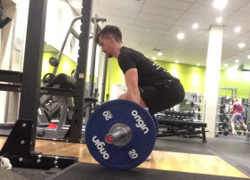

the floor up to the hips, as this is the most efficient bar path and will facilitate safer, heavier lifts.

When setting up, start with the feet directly under the bar with the bar nearly touching the shins and keep the bar tight to the shins and thighs as you stand.
4) Dropping Hips too Low
Starting with the hips too low causes the movement to become too similar to a squatting movement. In doing this, you are only making the exercise more difficult and less safe by failing to engage the correct musculature.

In the setup, ensure that your hips are higher than the knees and avoid sitting the bum back which will ensure that the glutes and hamstrings take the load.

5) Bouncing the Bar
Bouncing the bar uses momentum to assist the lift rather than generating the force from the muscles. It may also place the back in an unsafe position.

The solution is simple. Take your time between repetitions. As soon as the weight hits the floor, take a second to reset and then continue. This will eliminate the risk of bar bouncing and thus increase the safety and efficiency of the deadlift.
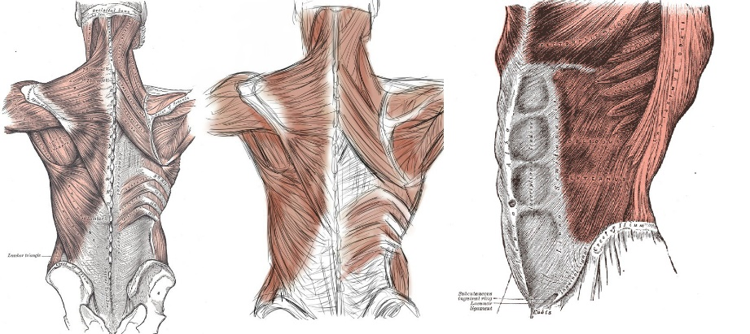

The
Core
What does the core refer to?
Often when people refer to the core they are referring to the rectus abdominis muscle however, the core consists of a lot more than just the muscles in the abdomen. It may be a surprise to you to know that muscles contained within the back, hip, shoulder and neck are all part of the core. In actual fact, the core refers to all musculature out with the legs and arms. There are thought to be at least 35 muscles that make up the core.
The Importance of a Strong Core
Having a strong core can have a impact on your day-to-day living. The primary function of the core is to help stabilise the body during movement. Therefore, having a strong core will improve balance and stability during movement or exercise which will have a direct impact on injury prevention.
Also, many individuals experience back, shoulders and neck pain as a result of being seated for prolonged periods and poor posture. The development of strong core musculature will help to facilitate good posture, preventing postural dysfunction, muscular pain and muscular imbalances.
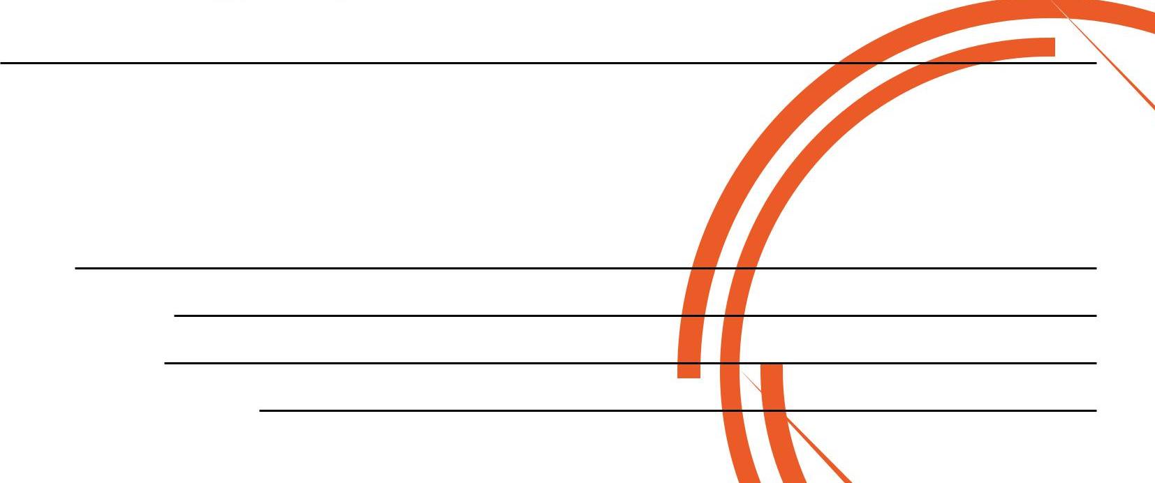
How to Build a Strong Core
Focus on compound lifts (these are “big” lifts that require work from many muscles throughout the body – for example, squats, deadlift, overhead press etc…
Why Compound Lifts Help to Build a Strong Core
Remember that the main function of the core is to stabilise and control movement. During big lifts exercises the core must engage in order to stabilise and control the body whilst being subject to numerous forces. Over time, these muscles will adapt and strengthen as a result of being subject to these forces.

If you would like to book in for a Complimentary Personal Training Session please fill in your details, tear off the slip and hand it in to reception and I will contact you as soon as possible.
Alternatively, please feel to get in contact with me directly at chris.stone@nuffieldhealth.com

Name:
Phone number:
Email address:
Preferred day and time:

