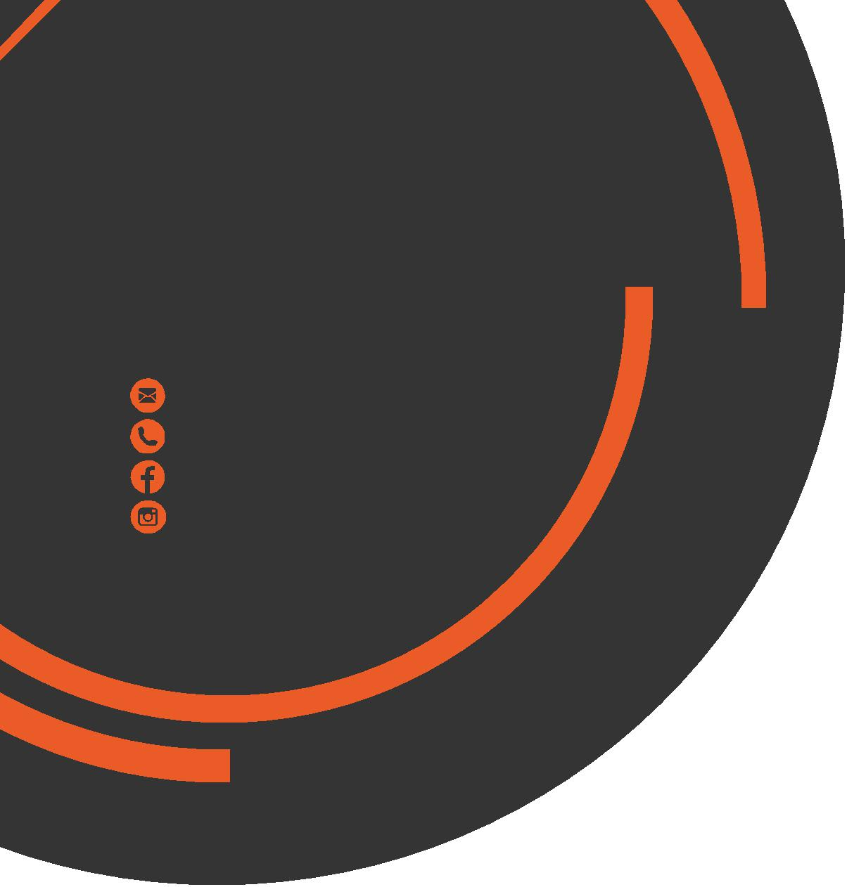
August
Newsletter
chris.stone@nuffieldhealth.com
07564666471

facebook.com/chrisstonept

chrisstonept

Static v Dynamic…
Which is the “better” stretch?
Do you ensure you always warm-up properly? An adequate warm-up is an extremely important element of any workout or exercise. If a warm-up is skipped (which it often is by many), overall performance may be negatively affect but more seriously, the chance injury is increased.
What is the purpose of a warm-up?
Quite simply, a warm-up’s purpose is to prepare the body for exercise.
How does a warm-up prepare the body?
- Increases body temperature
- Elevates heart rate
- Improves circulation
- Improves proprioception (Sense of movement)
- Increase elasticity of muscles and tissues
What is the difference between a static and a dynamic stretch?
Static - where the muscles are lengthened to the point of discomfort and held in position.
Dynamic - where the muscles are stretched through movement.


Personal Training
with Chris Stone
For more, visit my blog at: chrisstonepersonaltraining.com


Should I stretch Statically or Dynamically?
Use both. Dynamic prior to exercise, static after exercise.
Unfortunately, static stretching often has very little relevance to the activity you are about to take part. Dynamic stretching, however, uses movements which will be required in the forthcoming workout thus effectively readying your muscles in a more efficient manner.
Stretching the muscles statically can help to reduce muscular tension and aid relaxation and therefore should be incorporated as part of a cooldown.
Does Static Stretching reduce Power Output?
Several scientific studies exist which have examined the relationship between static stretching and its impact on muscular force.
Recent findings indicate that static stretching could negatively impact muscular power and therefore impact performance. However, more research needs to be done to confirm this.

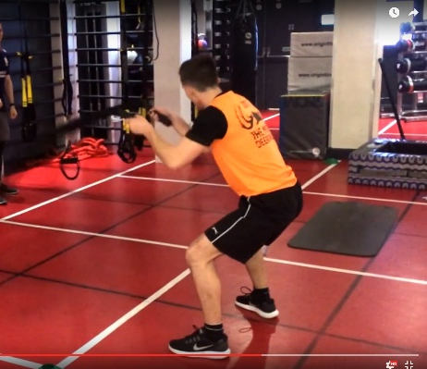
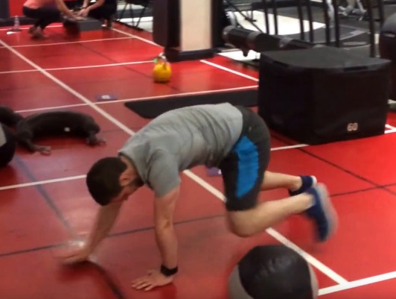

The
B
Blast
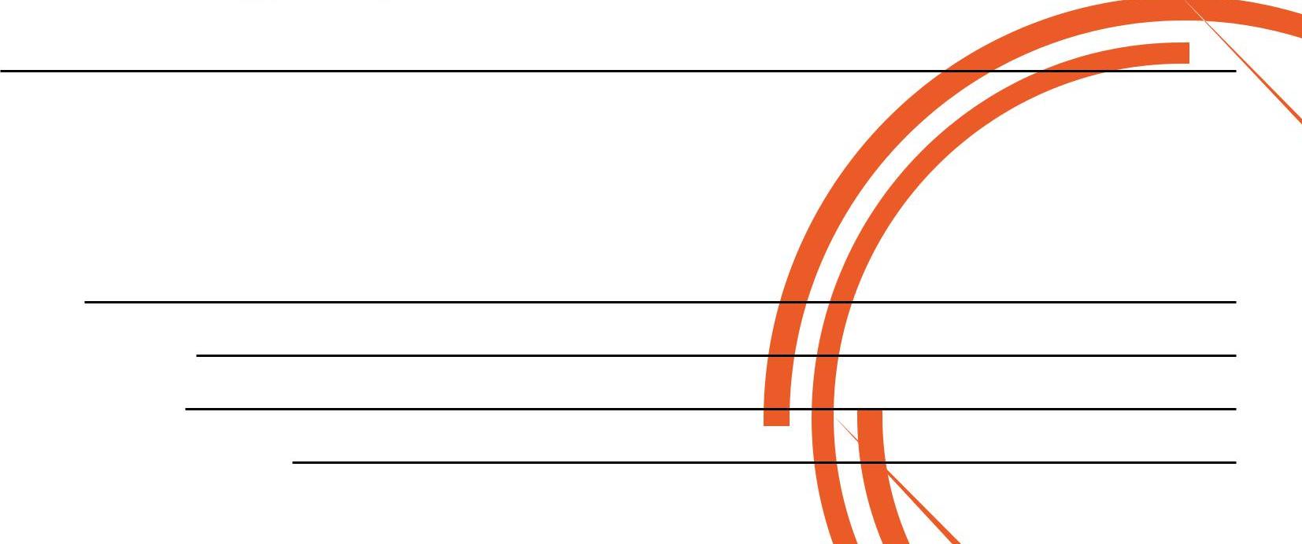
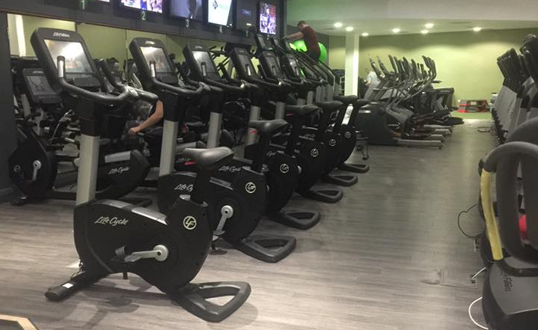
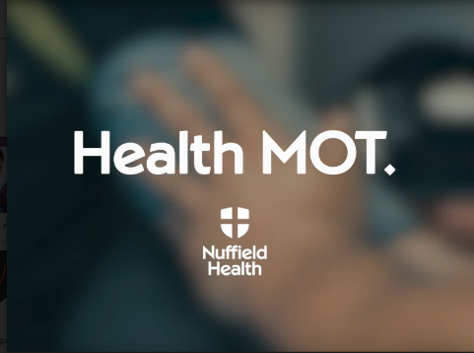
Try this very simple HIIT workout!
Nuffield One Year Anniversary
Saturday 19th August
On Saturday 19th August we will be running a birthday event to celebrate 1 year since Nuffield Health opened here at Fountain Park. On this day, there will be additional classes, seminars, workshops, MOT’s and café samples for you to try.
I will be running a Health MOT Seminar in the Café on this day.
The seminar will last 20 minutes and will cover:
- The Physiology of the Health MOT - The Assessments - Health Implications

Visit my Facebook Page
(Chris Stone Personal Training) and you can find a Video Demonstration of the B Blast pinned to the top of the page.
Workout Setup
Set 1: 30s work : 15s rest
Set 2: 30s : 10s
Set 3: 30s : No rest
The Exercises
- Bear Crawls
- Battle Ropes
- Ball Slams
- Box Jumps

If you would like to know more about Personal Training please fill in your details, tear off the slip and hand it in to reception and I will contact you as soon as possible.
Alternatively, please feel to get in contact with me directly at chris.stone@nuffieldhealth.com

Name:

Phone number:

Email address:

Preferred day and time:

