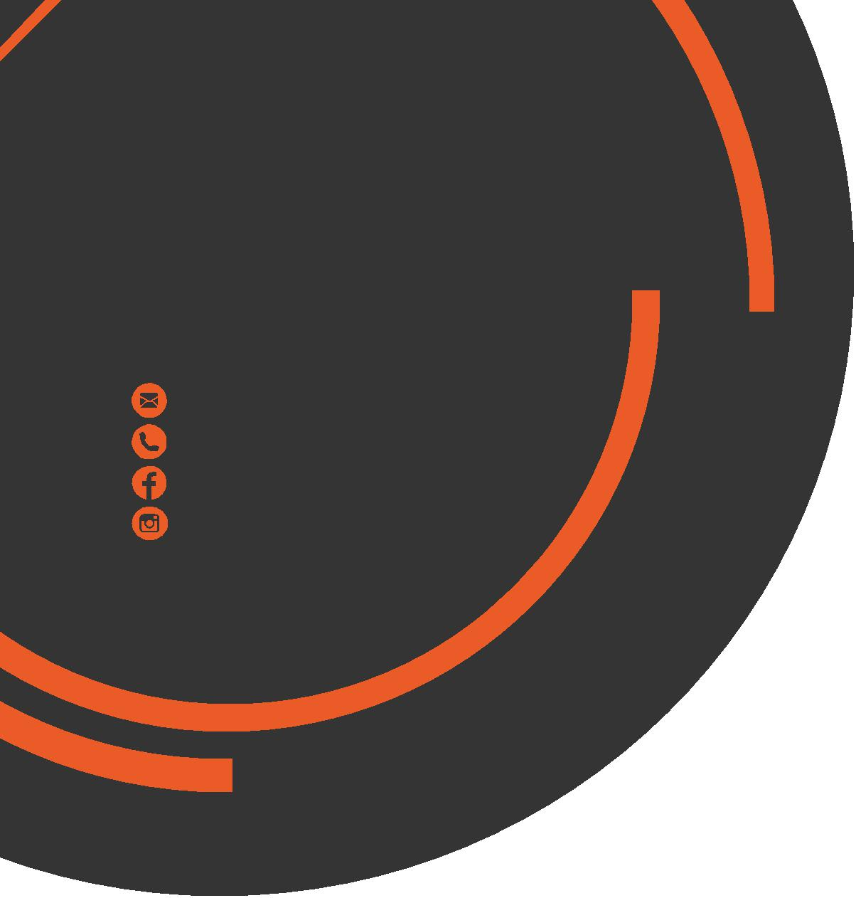
July
Newsletter
chris.stone@nuffieldhealth.com
07564666471

facebook.com/chrisstonept

chrisstonept

Fasted Cardio…
The Best Way to Burn Fat?
What is Fasted Cardio?
Quite simply, fasted cardio is when cardiovascular exercise is performed without having anything to eat prior to exercise (typically performed first thing in the morning).
Why is it done?
Normally, the body will use carbohydrates (gained through food) for fuelling the body. However, when no carbohydrates are present, the body will break down fat stores and use them as energy to fuel movement.
What does Science say?
Two recent studies compared non-fasted and fasted cardio and the impact of fasted cardio on body fat reduction. The studies did not support the use of fasted cardio as an efficient method of body fat reduction and no significant difference was found between both fasted and non-fasted cardio. One of the studies indicated that fasted cardio could actually have a negative impact on muscular strength and growth!


Personal Training
with Chris Stone
Visit my online blog at: chrisstonepersonaltraining.com

Fasted Cardio and The Calorie Deficit
Focus on calories rather than focussing on the specific Fat Loss “method”. The body needs to be placed within a calorie deficit to bring about Fat Loss. This basically means you must be consuming less calories per day than your body requires. This is where an argument about Fasted Cardio fails.
Let’s take an individual who performs regular fasted cardio. As soon as they wake they head to the gym without eating anything to complete some cardio. As the day goes on they consume too many calories which takes them out of the calorie deficit. As a result, they will not see changes in body fat until they reduce their calorie intake to an adequate level. It’s got nothing to do with fasted cardio or methods of training and everything to do with calories consumed per day.


Summer
of
Wellbeing

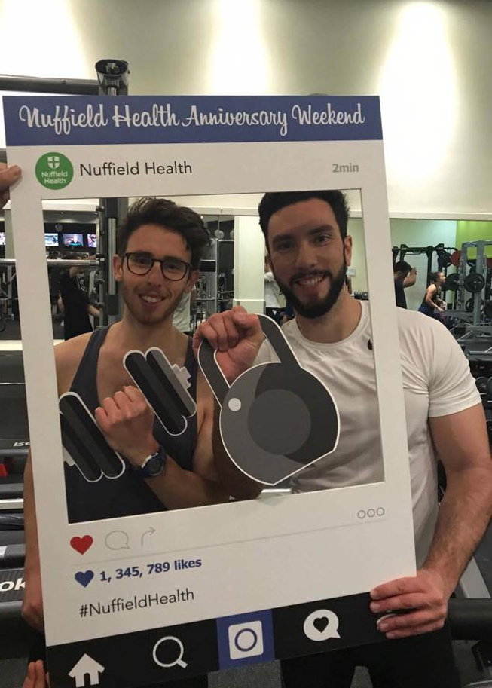
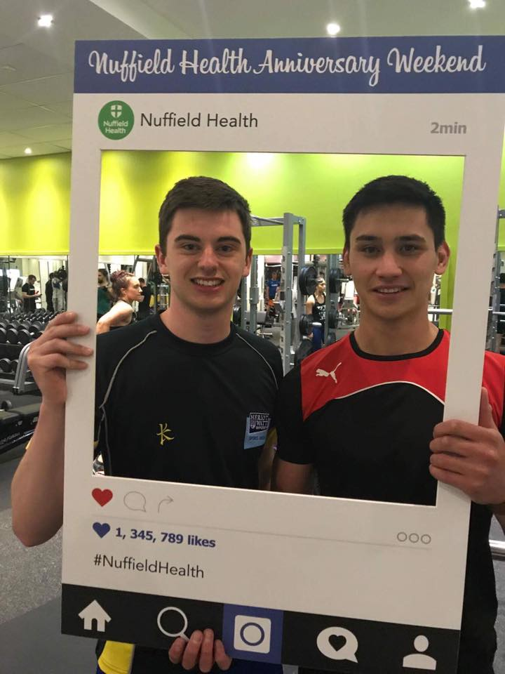
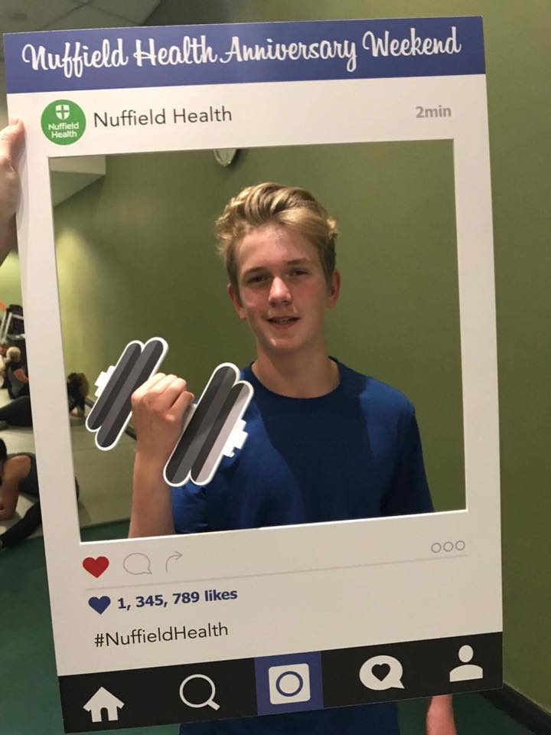
On Saturday June 24th 2017, we ran our Summer of Wellbeing Event. There were several activities and events run on the day including:
- Additional Gym Floor Classes - Seminars (Health MOT, Stress Management)
- Free Café Samples - Equipment Tutorials (Watt Bike, TRX) -HMOT’s
Keep an eye out for further events later on this year and make sure to get involved!
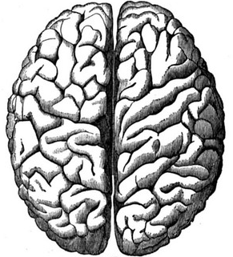
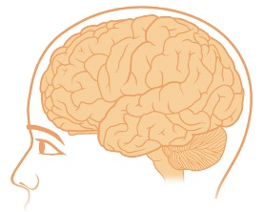
Anatomy Fact
Did you know?
The brain is divided into two sides or “hemispheres”.
The right side controls the muscles on the left side of the body.
The left side controls the muscles on the right side of the body.
The left side tends to be the more logical side whilst the right side tends to be the more creative side.
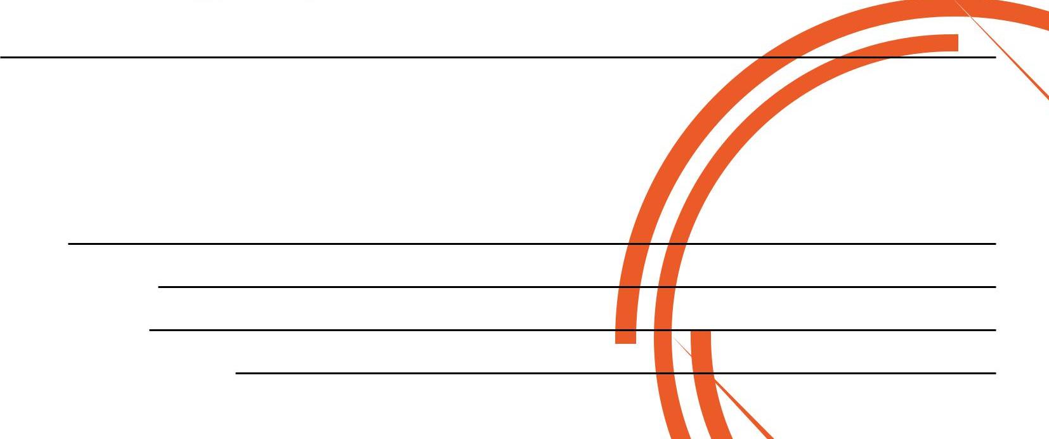

If you would like to know more about Personal Training please fill in your details, tear off the slip and hand it in to reception and I will contact you as soon as possible.
Alternatively, please feel to get in contact with me directly at chris.stone@nuffieldhealth.com

Name:

Phone number:

Email address:

Preferred day and time:

