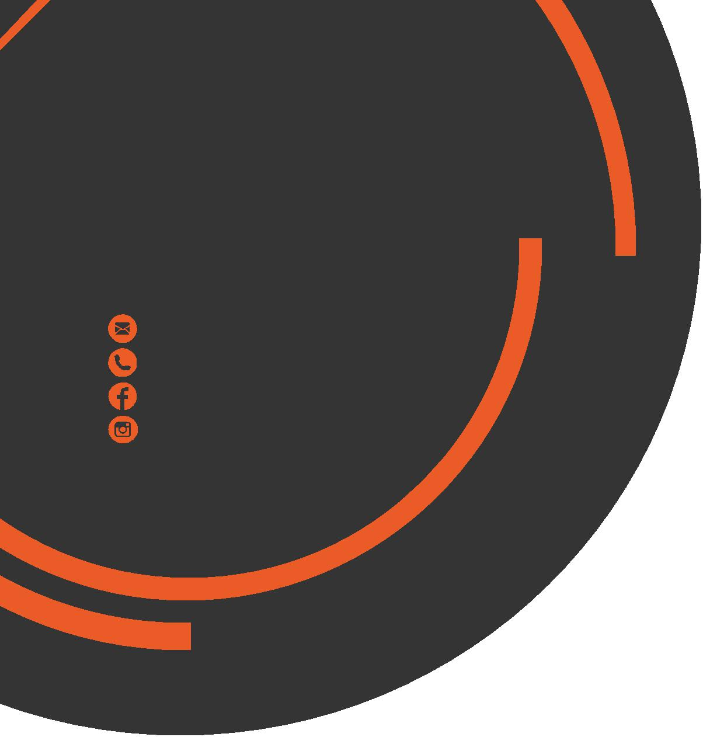
June
Newsletter
chris.stone@nuffieldhealth.com
07564666471
facebook.com/chrisstonept
chrisstonept

Client Testimonal
“Chris is a fantastic PT – always goes the extra mile to ensure he develops a customised training plan that you enjoy and even uploads these for you to access at any time.

He is fun, knowledgeable, enthusiastic and patient (much needed in my case!). Chris is more than happy to research and provide answers to any questions relating to nutrition, anatomy and training. I am well on my way towards achieving my goals.
Would highly recommend!”

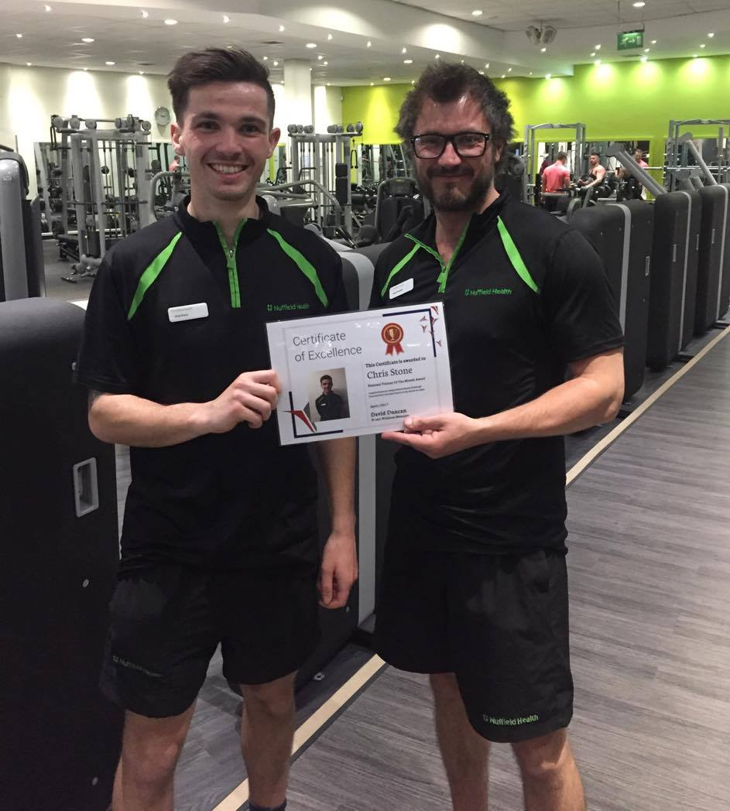
PT of the Month for April!

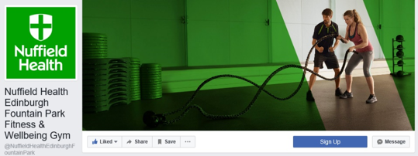Make sure to like our Nuffield Health Edinburgh Fountain Park Facebook page for the latest updates from your club!
“If you do what you love, you’ll never work a day in your life”.
I aim to put everything into what I do – whether that’s with programme design, training clients, blog posts or taking classes. I pride myself on providing a professional and effective service. So if you’re looking for that extra motivation, knowledge or assistance then get in contact!


Personal Training
with Chris Stone

Visit my online blog at: chrisstonepersonaltraining.comFor a host of interesting posts on effective training, the human body, nutrition and more!
On the following page you can access a really simple full-body workout that I love to use with many of my clients! It’ll get the heart pumping and the arms burning for sure!
The Battle Rope Workout.. Continued overleaf...
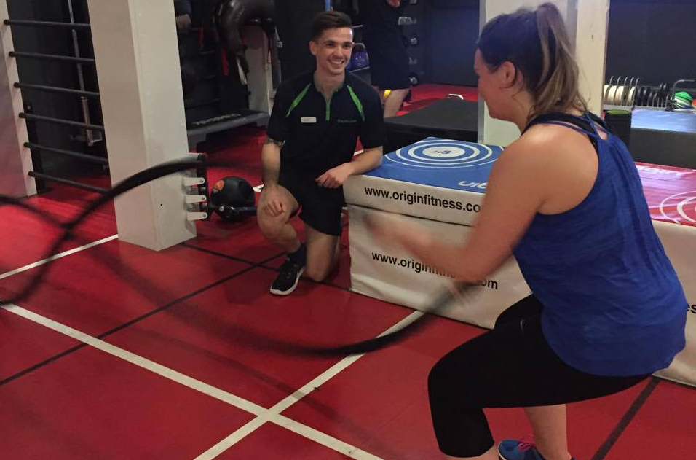

The Battle
Rope Workout

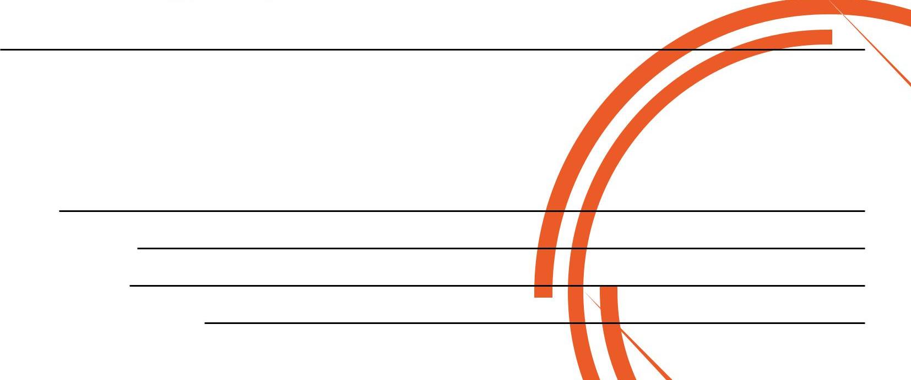
Battle Rope Basics:
- Feet planted on the floor, roughly shoulder width apart - Keep the chest lifted and shoulders back
- Crouch down slightly and hold a rigid position. This will keep the legs and core engaged throughout.
- Stand an adequate distance back to ensure there is tension on the rope before you start
- Avoid swinging the upper body. Remember that force should be generated from arms and not from a total body movement.
The Exercises
1) Alternate Waves 2) Paired Waves 3) Alternate Slams 4) Paired Slams
The exercises are very simple.
Alternate simply refers to moving the ropes upwards and downwards one at a time.
Paired refers to moving the ropes together at the same time.
For Waves, as fast as you can for the full 30 seconds and for Slams, slow it down and really drive the rope as hard as you can into the ground for full the 30 seconds.
For example, Paired Waves would mean together and as quick as possible whereas Alternate Slams would mean one at a time and hard.
For a full demonstration, visit Chris Stone Personal Training or Nuffield Health Edinburgh Fountain Park on Facebook!
Workout overview
Aim: Full-body workout
Set-up: 3 sets of 4 exercises
Work time: 30 seconds
Rest time: 15 – 30 seconds
1 minute rest between sets
(dependant on fitness level)

If you would like to know more about Personal Training please fill in your details, tear off the slip and hand it in to reception and I will contact you as soon as possible.

Alternatively, please feel to get in contact with me directly at chris.stone@nuffieldhealth.com
Name:

Phone number:

Email address:

Preferred day and time:

