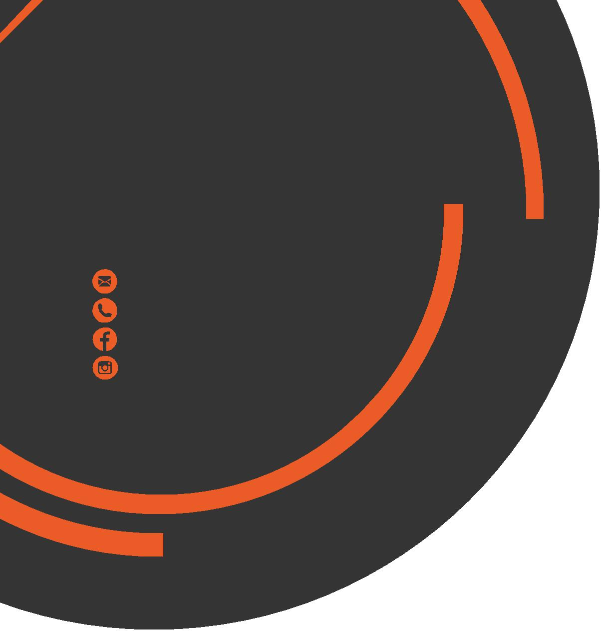
May
Newsletter
chris.stone@nuffieldhealth.com
07564666471
facebook.com/chrisstonept
chrisstonept

Nutritional Nugget
Q: How many calories are there in 1 gram of fat, carbohydrate and protein?
A: Fat – 9 calories
Carbohydrate – 4 calories
Protein - 4 calories

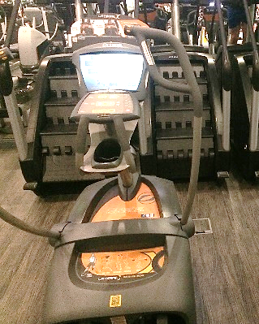
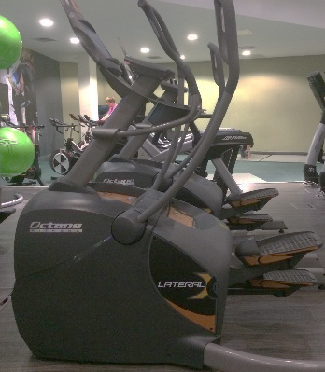
New Equipment – The Lateral Crosstrainer
With the recent refurb there are now lots of new pieces of kit to try out. You may have noticed one machine on the cardio platform and may be wondering what exactly it is and what it does. In this section I want to talk about the Lateral Crosstrainer and explain how you can get the best workout from it.
The Lateral Crosstrainer is not your standard crosstrainer. A standard crosstrainer moves the body in one plane (forward – backward motion). The lateral cross however moves the arms in a forward – backward motion and the legs in a circular motion. The width of the steps can be adjusted to make them wider or narrower to target specific muscle groups - hip abductors / adductors, glutes, quads and hamstrings.

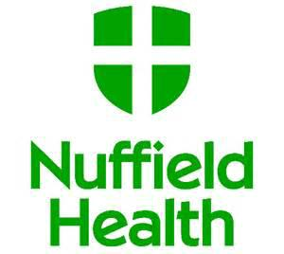
Lateral Cross Workouts
Using the Lateral Cross is simple – just get on and go. Take a few minutes to get used to the movement. Built into the machine are three different workout modes.
Pressing X-Mode will generate numerous commands for you to complete while exercising. There are 8 commands – they are “Push/Pull, Center Body, Shift Body, Lower Body Only, Lean Back, Reverse, Squat and Fast. A selection of commands will be highlighted for you to perform for a full 30 seconds followed by one full minute’s rest before another set of commands are given.
Selecting Thigh Toner will adjust the lateral width (or step width) based on how fast you are going. The faster you go the wider the step becomes. The slower you go the narrower the step becomes.
Lastly, choosing Quad Power, like Thigh Toner, will adjust the lateral width the faster you go. The difference between Quad Power and Thigh Toner is that the harder you work the more resistance will be applied by the machine. So, a wider step and increased resistance = legs burning!
So what are you waiting for? Now you know how the Lateral Cross works, go and give it a go!
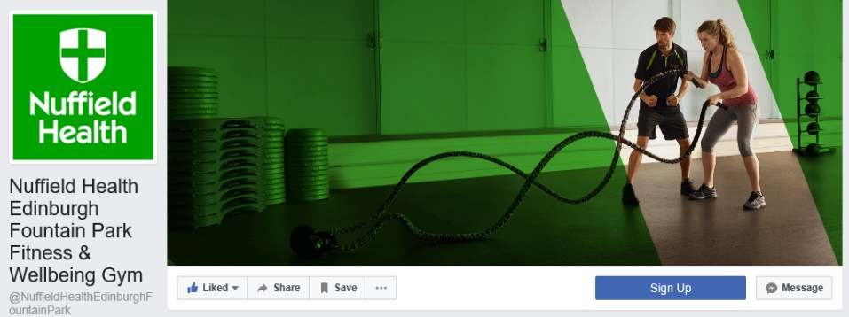

Muscle
Fibre
Types
If you haven’t done so already, make sure to like our Nuffield Health Edinburgh Fountain Park Facebook page for the latest updates from your club!
What is a muscle fibre? A muscle fibre is a single cell of a muscle.
There are three different muscle fibre types that can be found within the human body.
They are known as Type 1, Type 2A and Type 2B.
Type 1 or “slow twitch” muscle fibres are characterised by being extremely resistant to fatigue. They can produce low force contractions over a prolonged period of time, have a great blood supply, a large amount of myoglobin (a protein which carries and stores oxygen in muscle cells) and contain a large number of mitochondria (cellular structures which assist in energy production).
Exercise example: Long-distance running.
Type 2B or “fast twitch glycolytic” muscle fibres are the opposite of Type 1 and are characterised by their explosive nature. These fibres contain relatively few mitochondria. Energy is generated through the anaerobic (without oxygen) metabolic process which as a result causes the muscles to fatigue quickly and exercise at such a high intensity cannot be sustained for a prolonged period. This is the reason why you cannot sustain a long duration.
Exercise example: 100 metre sprint
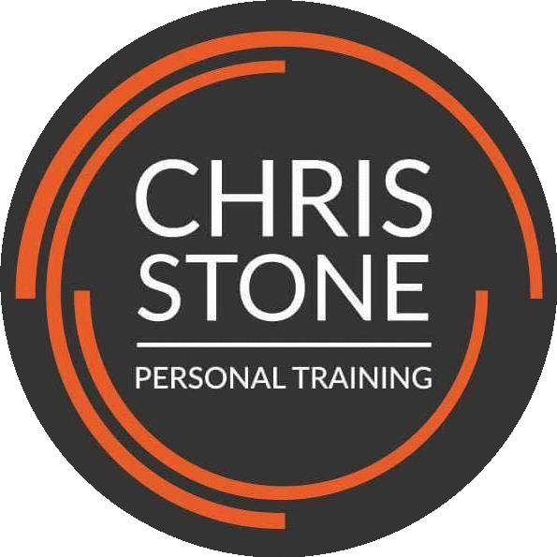


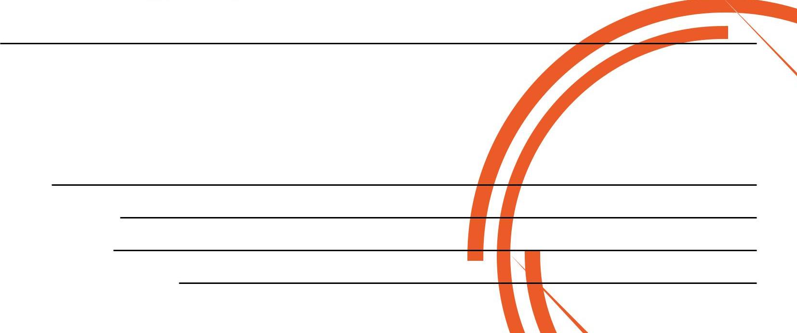
Type 2A or “fast twitch” muscle fibres are a fusion of both Type 1 and 2B fibres. They contain a large number of mitochondria and myoglobin and are able to produce energy with and without the presence of oxygen. They are also resistant to fatigue up to a certain limit.
Exercise example: Running the 400 metres
Type 2A fibres are the only fibres that will adapt to become more like another fibre type. Therefore, if an individual started regular sprint training these fibres would adapt to become more like Type 2B fibres whereas if they began marathon training they would adapt and become more like Type 1 fibres.
For more articles like this visit - www.chrisstonepersonaltraining.com/blog
You can also follow and like my Instagram and Facebook pages - @chrisstonept

If you would like to know more about Personal Training please fill in your details, tear off the slip and hand it in to reception and I will contact you as soon as possible.

Alternatively, please feel to get in contact with me directly at chris.stone@nuffieldhealth.com
Name:

Phone number:

Email address:

Preferred day and time:

