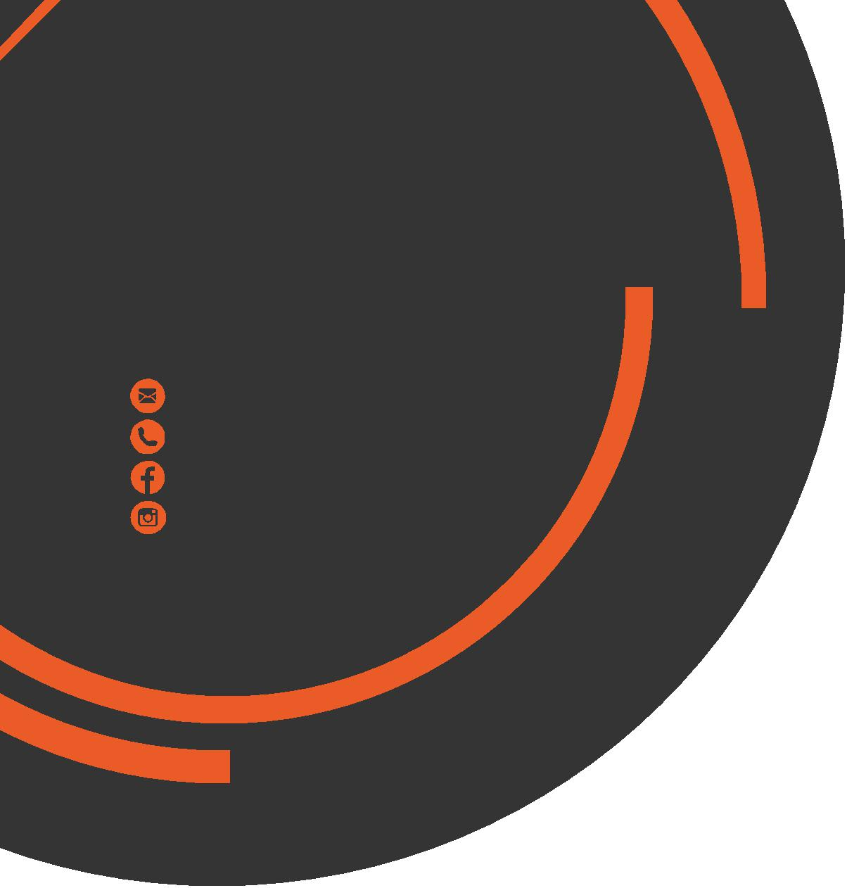
April
Newsletter
chris.stone@nuffieldhealth.com
07564666471
facebook.com/chrisstonept
chrisstonept

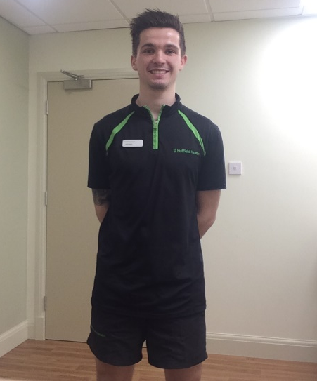

Individuals who set themselves goals or targets are far more likely to make progress and attain their goals than those who don’t...
Goal Setting
Setting SMART goals is important when considering what it is you want to achieve. SMART is an acronym which stands for the following:
Specific – Focus on one particular aspect or
component of fitness
Measurable – Regularly assess yourself so you can
make any necessary changes
Achievable - Focus on achieving something
(for example, learning the squat
or completing a marathon)
Realistic – Unrealistic goals are unlikely to be
attained and can demotivate.
Take small steps.
Time-Bound – Ensure to set a time or date by which
you hope to have reached your goal
to help keep you on track

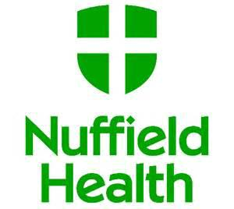

Personal Training
with Chris Stone
---------------------------------------------- Trainer Profile
--------------------------------------------------------
Name: Chris Stone Age: 23
Joined Nuffield: November 2016
Likes: Motorcycles and Linkin Park
Dislikes: Elevators and Gin
Specialities: Anatomy, Pre/Post Natal, Speed, Agility and Plyometric training
If you see me in the gym, come and say hi!
You can follow my online blog at: chrisstonepersonaltraining.com
-------------------------------------------------------
Smart Goal Example
Lets say for example, I want to be able to squat 100kg by July.
S – Focusing on one exercise – The Squat
M – Measureable by weight lifted
A – Yes - have experience with this exercise
R – Yes – weight set (100kg) isn’t unrealistic
T – Set “deadline” for July time
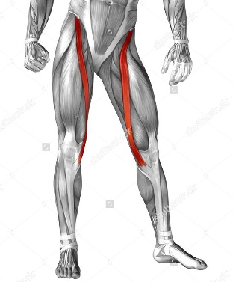

Anatomy Fact
Q: Do you know where to find the
longest muscle in the human body?
A: The upper leg.
The Sartorius muscle begins at the pelvis (ilium) and runs down the length of the thigh attaching to the upper tibia (bone in the lower leg)
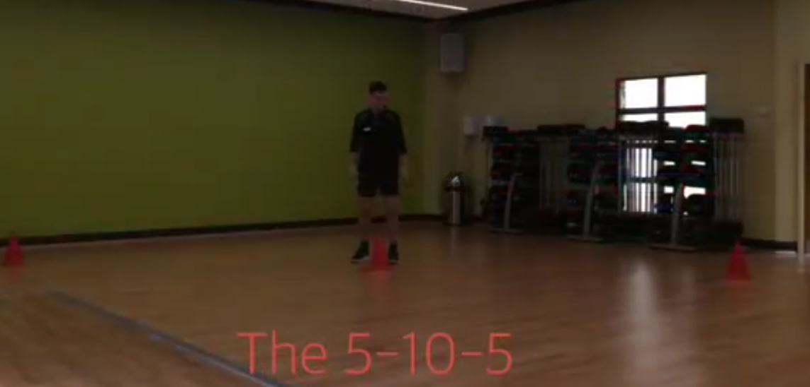
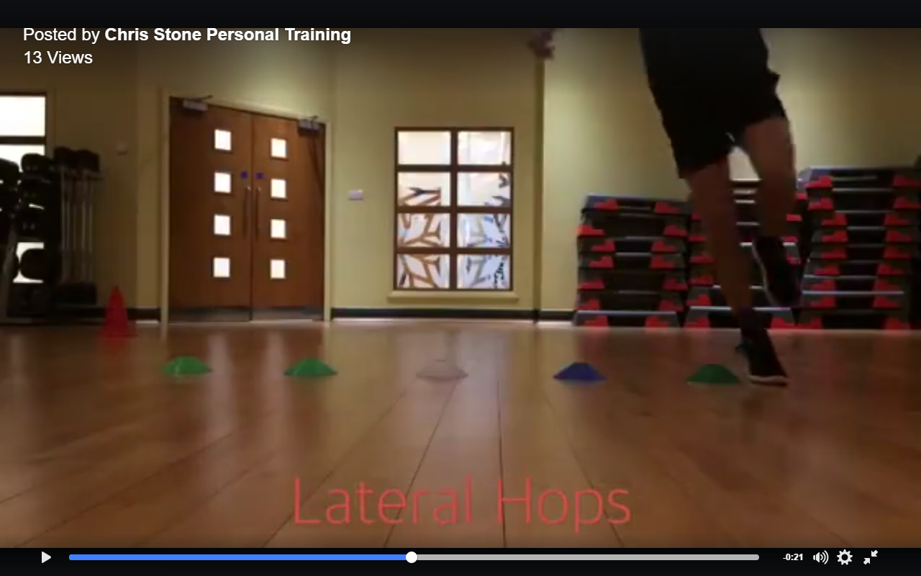
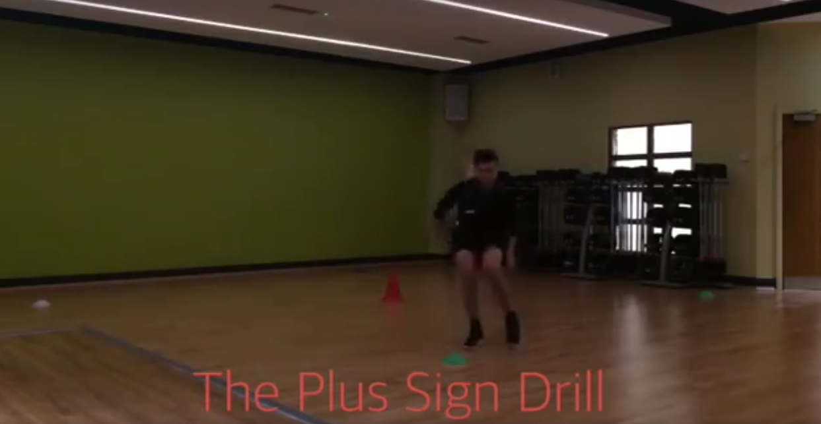
Developing
Speed
Looking to improve your athletic performance? Gain that extra yard or two?
Or maybe add some variety to your training? Then try these 3 speed drills...
Speed
What exactly is the definition of speed?
Speed is the ability to move to the body or limbs very quickly.
The Exercises:
1) The Plus Sign Drill 2) Lateral Hops 3) The 5-10-5

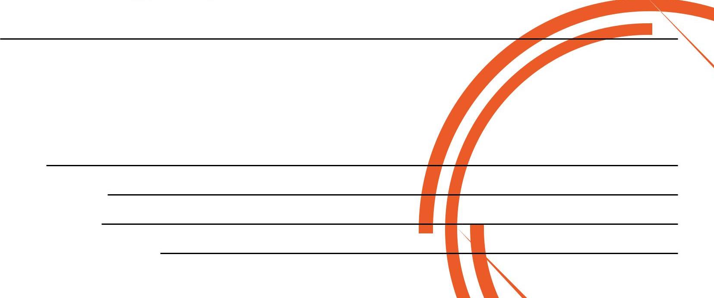
- 5 cone setup - 5 cones in a line - 3 cones in a line
(Middle, Front, Back, Left, Right) - One-legged hops between (5 yards apart)
- All cones 5 yards from middle cone the small gaps - Run 5 yards to the
- Start from middle, work it backwards, - Swap legs and same again left, 10 yards to the
return to middle, to the left and right, right cone, then 5
then forward yards to the middle
Visit Chris Stone Personal Training or the Nuffield Health Edinburgh Fountain Park page for a video demonstration!
Keep an eye out for a BRAND NEW class coming soon.
Many of you may already be aware or may even have registered your interest, but I intend to start a Speed, Agility and Quickness (SAQ) class in the near future.

If you would like to know more about Personal Training please fill in your details, tear off the slip and hand it in to reception and I will contact you as soon as possible.

Alternatively, please feel to get in contact with me directly at chris.stone@nuffieldhealth.com
Name:

Phone number:

Email address:

Preferred day and time:

