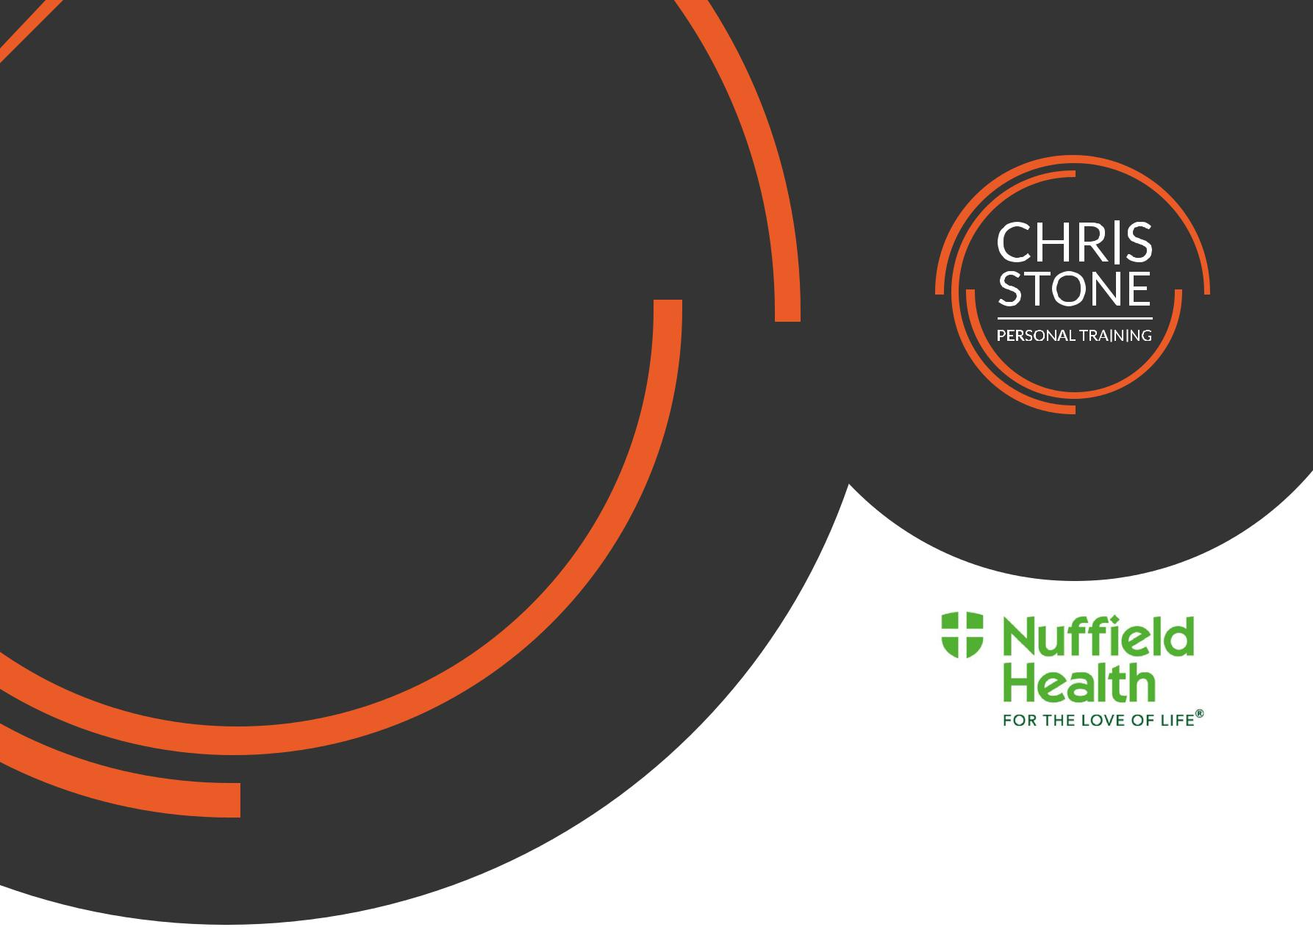
January
Newsletter




chris.stone@nuffieldhealth.com 07564666471
@chrisstonept

New Year, New You?
Happy 2017!
Made big plans for the year ahead? Perhaps looking to shed some of pounds after the Festive period? In this section, I hope to give you the tools and knowledge you need to accomplish it.
Basal Metabolic Rate (BMR)
The first thing to do is to calculate your BMR which is the number of calories your body burns at rest.
It may be a test of your basic maths skills but it’s well worth doing!
(Write your result in the box)
M | 10 x weight (kg) + 6.25 x height (cm) – 5 x age + 5 =
F | 10 x weight (kg) + 6.25 x height (cm) – 5 x age – 161 =
Creating an energy deficit
Once you’ve calculated your BMR you can then begin to create an energy deficit to help you lose body fat. Basically, you must consume less calories per day than your body requires (BMR).

You want to look at creating an energy deficit of around 500 calories per day which can be achieved by following one of these methods:
- Reduce dietary intake by 500 calories per day
- Increase exercise levels by 500 calories per day
- Increase exercise/activity by 250 calories per day and reduce dietary intake by 250 calories
The last method, combining a reduction in calorie intake and an increase in activity levels, would be recommended as it is most efficient and manageable option.
January Blast!
Follow this simple 15 minute High Intensity Interval Circuit designed to blast away the calories!
If you’re unsure on how to complete these exercises, an instructional video can be found on Facebook (@chrisstonept).
The Exercises:
- Maximal Battle Ropes Slams
- Tyre Flips with Push-up
- Kettlebell Squats
- Woodway Curve Sprints
30 seconds high intensity work
10 seconds rest between exercise
1 minute rest between sets
3 – 5 sets

-
Nutritional Nugget
DID YOU KNOW?
It is recommended to eat 2 portions of fish a week?
This is because your body cannot make Omega-3 (a polyunsaturated fat) which has been shown to lower the risk of heart attacks and may also help to prevent heart disease.
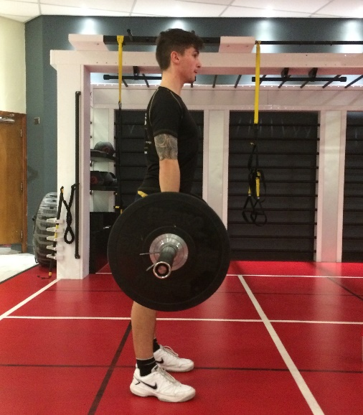
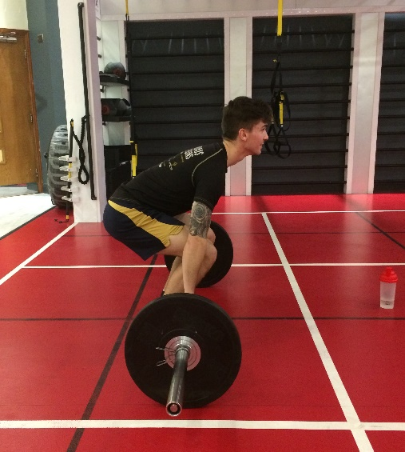
Exercise Analysis
- Deadlift
Why Deadlift?
- Efficient development of lower body strength and power
- Strengthening of muscles all round the body
- Builds core stability and consequently improves posture and balance
- It’s a total body exercise that works more muscles simultaneously than any other movement
- Improved grip strength
Muscles Involved:
- Upper Leg: Quadriceps, Hamstrings, Glutes
- Back: Latissimus Dorsi, Rhomboids, Trapezius, Erector Spinae
- Other: Rectus abdominis, Upper and Forearm Musculature
- Start Position
How to Deadlift
- Stand with feet at hip width apart with the bar nearly touching your shins
- Feet pointing forward or very slightly pointed out
- Bend at knees and hinge hips to lower body
- Grip bar at slightly greater than shoulder width apart
- Lift the bar upwards by driving up using your legs,
- Keep feet flat on the ground at all times and drive through your heels
- Lift chest to avoid rounding or flattening your back
- Drive the hips through towards the bar whilst squeezing the glutes
- Bar should be raised to thigh level and then returned to floor keeping chest up, bending from the knees and hinging hips to safely lower the bar
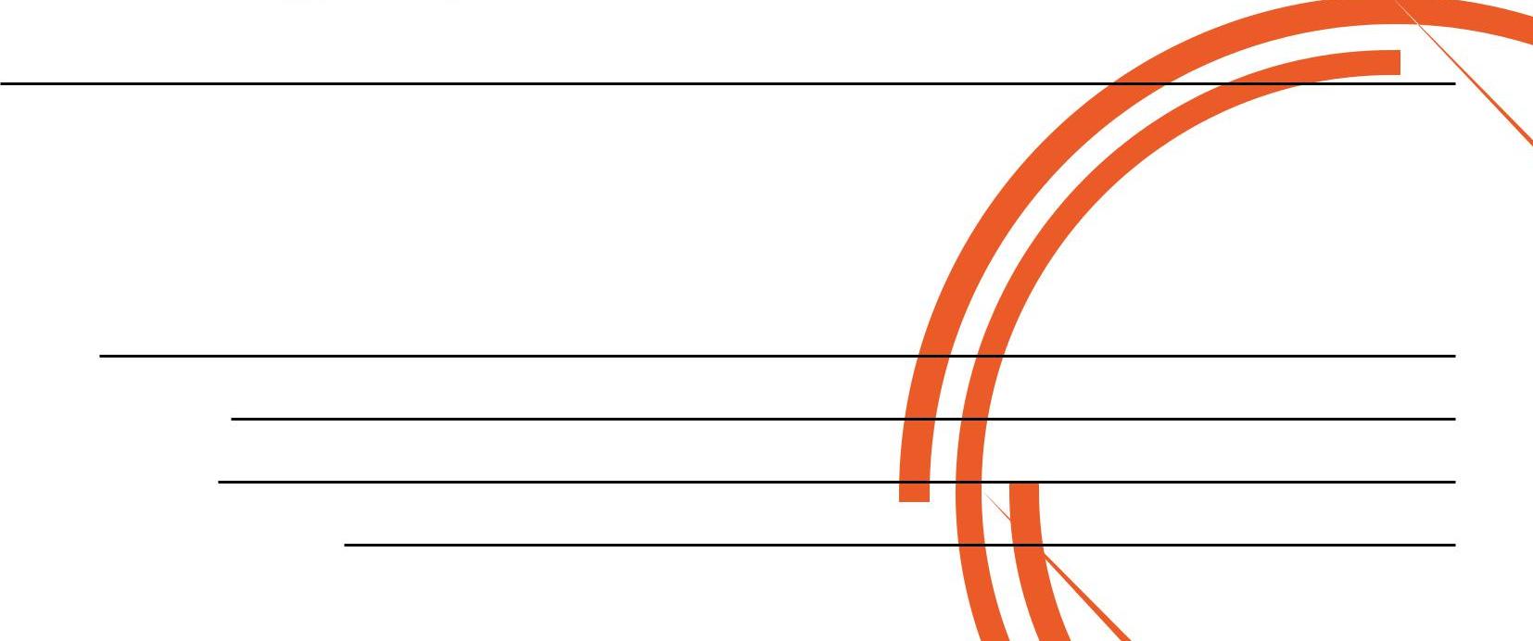
- If you are new to deadlifting, keep the weight low initially and practice the movement often to ensure you learn the correct form
- End Position
If you would like to know more about Personal Training please fill in your details, tear off the slip and hand it in to reception and I will contact you as soon as possible.

Alternatively please feel to get in contact with me at chris.stone@nuffieldhealth.com
Name:

Phone number:

Email address:

Preferred day and time:

