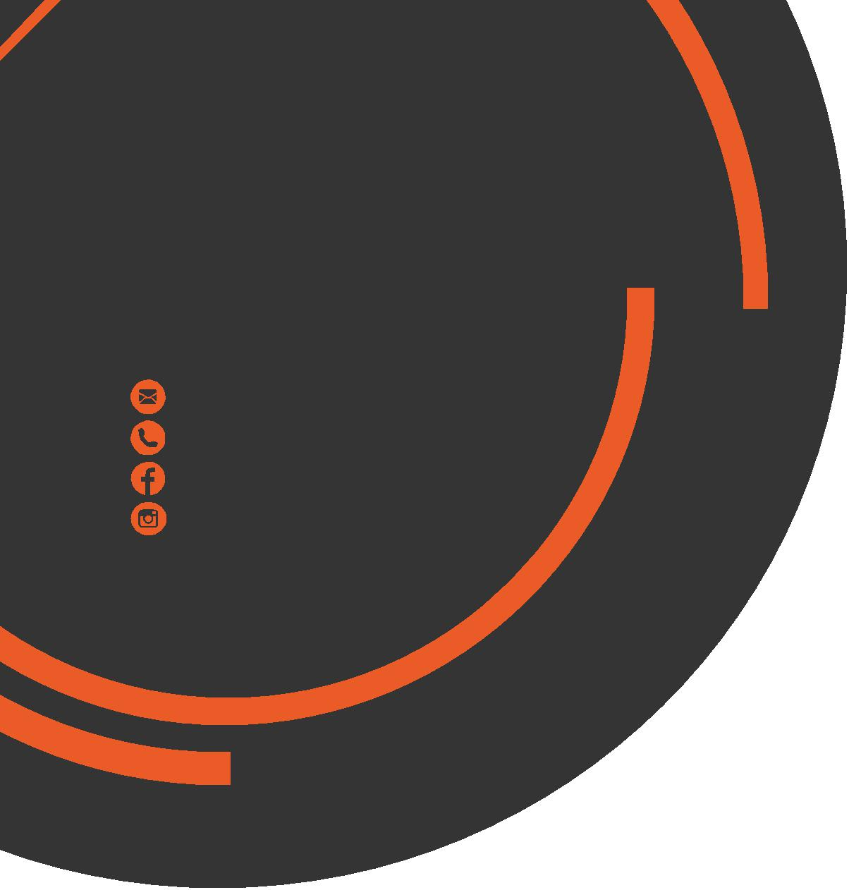
February
Newsletter
chris.stone@nuffieldhealth.com

07564666471 facebook.com/chrisstonept
chrisstonept

Preparing for a running event?
In this month’s newsletter I’m going to look at preparing for a running event and what you can do in order to get across that finishing line!
Heart Rate Training
Using a form of training known as Heart Rate Training is a great way to ensure that your body is suitably ready when race day comes.
- Maximum Heart Rate (MHR)
To determine which training zone you should be using you must first work out your MHR which can be done by following this simple formula:
220 – Age (years) = MHR
I am 23 years old, therefore my MHR would be:
220 – 23 (age) = 197 beats per minute (bpm)
Write your MHR in the box below!
MY MHR = | 220 - ______ = _______ bpm
Monitor Heart Rate during training by simply holding on to the metallic plates found on the treadmills, crosstrainers and stationary bikes in the gym.
Alternatively, you can use Heart rate monitoring equipment.



Personal Training
with Chris Stone

- Heart Rate Training Zones

Zone | System | % of MHR
1 | Recovery | 50-60
2 | Aerobic 1 | 60-75
3 | Aerobic 2 | 75-90
4 | Anaerobic 1 | 90-95
5 | Anaerobic 2 | 95-100
Aerobic = with oxygen Anaerobic = without oxygen
The zones highlight in orange are the zones to focus on.
Training within Zone 1 will aid recovery and can be used after an intense workout to promote blood flow to muscles which can help to reduce muscle soreness and fatigue.
Training within Zone 2 should be utilised initially to bring about improvements in aerobic fitness and VO2 max (maximal oxygen consumption).
Training within Zone 3 is known as tempo or aerobic threshold training which will work on your race pace whilst also improving overall endurance.
Input your MHR into the blank spaces and calculate your Heart Rate Training zones!
Zone | % MHR | Ranges (bpm)
1 | ____ x 0.5 and ____ x 0.6
2 | ___ x 0.6 and ____ x 0.75
3 | ___ x 0.75 and ____ x 0.9
Example:
Zone 1 - (197) x 0.5 and (197) x 0.6 = 99 - 118 bpm
Zone 2 - (197) x 0.6 and (197) x 0.75 = 118 – 148 bpm
Zone 3 – (197) x 0.75 and (197) x 0.9 = 148 – 177 bpm

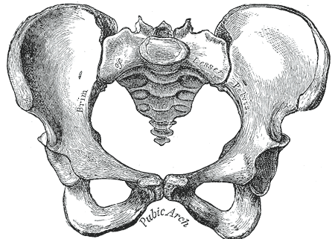
Foam
Rolling
Anatomy Facts
DID YOU KNOW?
Your pelvis consists of pairs of 3 connected bones called the ilium, ischium and pubis.
45 muscles connect to the pelvis both from the upper and lower body!
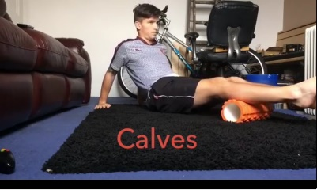
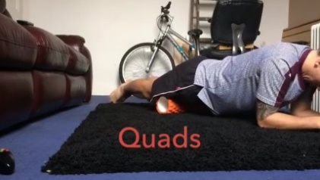
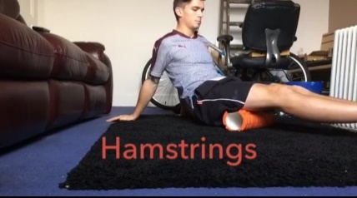
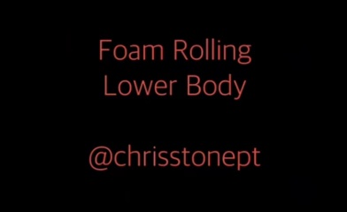
What is Myofascial Release?
Fascia is a connective tissue found in the body which surrounds muscles, bones and organs. More specifically, “myofascial” relates to the connective tissue that can be found surrounding muscles. “Myofascial release” is a massage technique used to relieve tense and sore muscles which result from having tight fascia.
Foam Rolling Benefits
- Improved flexibility / range of motion - Muscle soreness decrease - Improved circulation
- Enhanced recovery - Improved posture - Injury prevention
Foam Rolling Basics
- Slow down! Movement should be steady and controlled; no faster than an inch per second.
- Foam rolling should feel a little uncomfortable (a “good" pain) but should never cause intense pain. Avoid rolling an injured site as this will only lead to increased inflammation.
- Ensure that the pressure is sufficient to bring about myofascial release. Either by manipulating your bodyweight / body position or by using a higher density foam roller.
- Always roll in the same direction of the muscle fibers (up and down rather than across the muscle)
- If you find a particularly tight spot or "knot", it is fine to concentrate on that specific area to "loosen" it. However, the maximum amount of time you should spend on one particular area is around 20 seconds.
- Avoid rolling directly over a joint or on a bone
- Avoid rolling the lower back as it puts excessive pressure onto the discs of the lumbar spine and you will also be rolling directly on organs - specifically the liver and kidneys!
- Use a tennis ball or hard ball to directly target the soles of the feet, shins and shoulder.
You can find instructional videos on Foam Rolling on my social media pages! (@chrisstonept)
Also, look out for a Foam Rolling class taken by one of our Personal Trainers, Sam, starting in the near future!
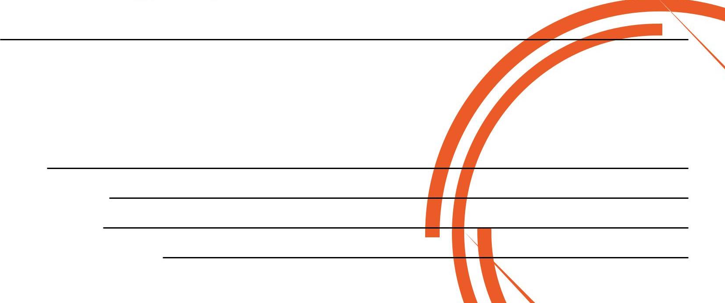
If you would like to know more about Personal Training please fill in your details, tear off the slip and hand it in to reception and I will contact you as soon as possible.
Alternatively, please feel free to get in contact with me directly.

Phone:
Preferred Date and Time:
Name:
Email:

